CASE STUDY 16 | HOMEPAGE FEATURED - RANK 4
Shopify Store E
₹2.07 Cr in total sales over the tracked year

1. Case Study Overview
This flagship Shopify growth case recorded ₹2.07 Cr in total sales, 19.06 L sessions and 26.3K orders. The source describes revenue beginning to climb in autumn 2025 and continuing to rise through each following quarter, with a monthly peak near ₹30 L.
The original source describes this as the flagship growth curve. Rather than presenting one month as the whole story, it shows a revenue line that started rising in autumn 2025 and continued upwards through the following quarters. The brand name, store category and detailed campaign plan are not disclosed, so the case focuses on the store-level sales trajectory and the Shopify totals supplied.

Performance snapshot from the original case record
Metric | Reported figure
Total sales | ₹2.07 Cr
Sessions | 19.06 L
Orders | 26.3K
Observed trend | Growth from autumn 2025 through subsequent quarters
Peak monthly sales | Near ₹30 L

Homepage position: Featured case #4 in the five-case homepage selection. The complete case remains part of the full case-study library.

BUSINESS CONTEXT

2. The Challenge
The visible challenge was to build sustained growth over a full year rather than depend on a short-lived spike. A store may record a strong month and then fall back; the source highlights a different pattern here, with revenue continuing to rise across successive quarters. The source does not disclose what individual marketing or operational changes took place during each quarter.
The challenge was not only to record one strong month. The case highlights a sales curve that kept moving upwards over successive quarters. Sustaining growth over that period is a different story from reporting one temporary peak, although the source does not detail the individual actions behind each step.

What made this case difficult
The case gives the total sales, sessions, orders, a broad timeline and a peak monthly value. It does not contain an exact monthly revenue table, so the precise growth rate from quarter to quarter cannot be calculated from the supplied document.

Practical effect on the business
Sustained growth requires a longer view than one month. The chart gives that longer view by showing a rising sales line across successive quarters. The remaining challenge for a full business review is to connect the trend to the channels, costs and operations behind it.

3. Objective
No pre-launch target or specific quarterly goal is included in the case material. The documented outcome is the scale and continuity of the sales trend: ₹2.07 Cr in total sales, 19.06 L sessions and 26.3K orders, with a monthly peak near ₹30 L.
No formal annual target is supplied. The case documents the scale reached during the tracked year and the continued rise in monthly revenue through successive quarters. The reported figures are outcomes, not proof that a pre-agreed target was met.

Objective and available success measures
Objective area | Evidence available in the source
Store revenue | ₹2.07 Cr total sales
Store traffic | 19.06 L sessions
Order volume | 26.3K orders
Growth trend | Sales rose across successive quarters; peak month near ₹30 L

APPROACH AND DELIVERY

4. Strategy
The source describes this as the flagship growth curve because sales increased over successive quarters rather than showing only one short-lived jump. Revenue began climbing in autumn 2025 and continued to rise through the following quarters, reaching a monthly peak near ₹30 lakh.
The original case does not list the advertising channels, campaign structures, audience segments, creative formats or budget changes behind the trend. The strategy that can be supported here is the sustained growth pattern across the tracked year. The Shopify totals show the scale of the store, while the chart shows how the result developed over time.

How the strategy addressed the business need
The store's sustained quarterly growth is the strategy-level story that the source can support. It shows a longer period of progress, even though the specific campaign plan is not disclosed.

Why this structure fits the case
The source calls this the flagship growth curve because it continued to rise over the tracked year. A long-running trend is a useful way to assess whether growth was sustained beyond one isolated month. The detailed marketing strategy remains undisclosed, so the chart should be the centre of the case rather than an invented campaign timeline.

5. Campaign Execution
The dashboard trend shows sales beginning to climb in autumn 2025 and continuing to rise through every following quarter. The monthly curve reached a peak near ₹30 L. This is the execution story supported by the source: sustained store growth over the tracked year. The source does not list campaign objectives, advertising spend, audiences, creative formats, budget changes or the specific channel mix. It also does not provide a monthly table that would allow every increase to be linked to a particular action. Those details are left out rather than guessed.

Documented sales timeline
Period / stage | What the original case record shows
Autumn 2025 | Revenue began to climb.
Following quarters | The sales curve continued to rise over successive quarters.
Peak month shown | Monthly sales reached close to ₹30 lakh.

The source does not show the campaign mix, audience settings, budgets or monthly changes behind the chart. The execution section therefore records the visible sales progression, not an invented campaign sequence.
The Shopify chart shows sales increasing from autumn 2025 through the following quarters, with a monthly peak near ₹30 lakh. This sustained movement is the execution evidence available in the source. There is no campaign-by-campaign history, media-spend record or channel breakdown to connect individual actions to each rise in the chart.

NUMBERS AND REPORTING

6. Performance Analysis

Reading the main metrics
The dashboard records ₹2.07 crore in total sales, 19.06 lakh sessions and 26.3K orders. The chart shows revenue rising from autumn 2025 through successive quarters, with a monthly peak near ₹30 lakh. The totals show store scale. They do not establish the amount attributable to paid ads or the store's profit.
The 19.06 lakh sessions show the scale of recorded traffic, and 26.3K orders show the volume of transactions alongside ₹2.07 crore in sales. The chart is significant because revenue increased through successive quarters and reached a monthly peak near ₹30 lakh. Without ad spend and attribution data, these figures describe store scale rather than advertising return.

What the figures do and do not show
The source does not disclose the store category, marketing channel mix, ad spend, gross margin, refund rate or exact monthly revenue series. Do not label the ₹2.07 crore as ad-generated revenue or profit.
Metric | Reported figure
Total sales | ₹2.07 Cr
Sessions | 19.06 L
Orders | 26.3K
Observed trend | Growth from autumn 2025 through subsequent quarters
Peak monthly sales | Near ₹30 L

Original Dashboard Evidence
The following images are the original screenshots supplied in the source case-study document. They are included as visual supporting evidence and have not been altered.
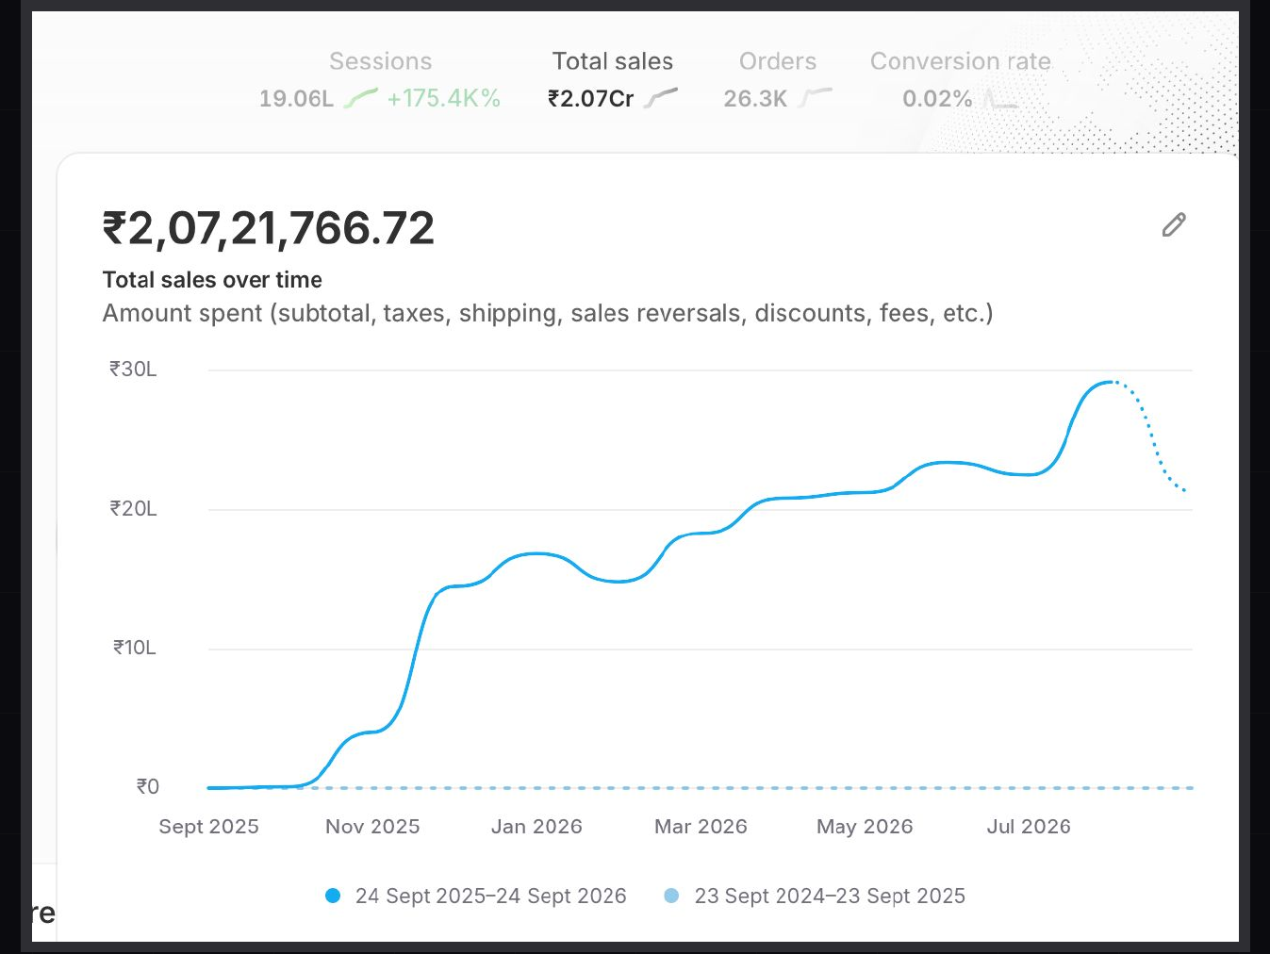
Figure 1. Shopify sales dashboard screenshot - original source image.

7. Results & Outcomes
The Shopify snapshot reports ₹2.07 Cr in total sales, 19.06 L sessions and 26.3K orders. Using the rounded totals, the simple sales-per-order ratio is approximately ₹787, while orders per 100 sessions are about 1.38. These are derived ratios rather than official Shopify AOV or conversion-rate values. The chart shows the sales line rising from autumn 2025 through subsequent quarters, with a monthly peak near ₹30 L. The annual total and trend together make this the largest store-sales case in the original set.
The dashboard total was ₹2.07 crore in sales, with 19.06 lakh sessions and 26.3K orders. The chart shows continued growth from autumn 2025 through successive quarters and a monthly high near ₹30 lakh.

What stands out in the result
The strongest part of the outcome is the sustained pattern across successive quarters, alongside the total sales and order volume. It gives the reader a sense of scale and duration rather than relying only on a large annual total.

8. Key Learnings
- A sustained growth curve over successive quarters is more informative than a single strong month.
- Use total sales, sessions, orders and the monthly trend together to show both scale and progression.
- Store revenue is not the same as paid-ad revenue or profit. Margin, channel attribution and repeat-purchase information would be needed for those claims.

BUSINESS VALUE AND CLOSE

9. Business Impact
The store recorded ₹2.07 crore in total sales, 19.06 lakh sessions and 26.3K orders. Revenue began climbing in autumn 2025 and continued rising across the following quarters, with a monthly peak near ₹30 lakh. The case is notable for the sustained direction of the curve as well as the annual total.
This is strong store-level evidence of scale and sustained growth. It should not be described as ₹2.07 crore of paid-ad revenue or profit. The source does not provide ad spend, channel attribution, margin, refunds or repeat-purchase figures.

Business decisions this case can inform
Decision area | What the case suggests | What should be checked next
Quarterly planning | Use the sustained sales curve for growth review. | Exact monthly totals and quarter comparisons.
Store operations | Use 26.3K orders to understand transaction scale. | Fulfilment, refunds, repeat purchases and stock.
Paid-media claims | Treat ₹2.07 Cr as Shopify total sales. | Ad spend, channel attribution and contribution profit.

10. Conclusion
This Shopify case records ₹2.07 crore in sales, 19.06 lakh sessions and 26.3K orders. Revenue rose from autumn 2025 through successive quarters, reaching a monthly peak near ₹30 lakh. It is the strongest store-sales scale example in the set, but the figure represents Shopify total sales rather than verified paid-ad revenue or profit.

Publishing accuracy note
The source does not disclose the brand name, product category, marketing channel mix, ad spend, ROAS, gross margin, refunds, repeat purchase or exact monthly revenue table. Sales-per-order and orders-per-session are approximate calculations from rounded totals. Do not describe ₹2.07 Cr as paid-ad revenue or profit unless separate records substantiate that claim.

