CASE STUDY 15 | SEE ALL LIBRARY
Shopify Store D
₹5.27 lakh in total sales with 1,636 orders

1. Case Study Overview
This Shopify store recorded ₹5.27 L in total sales, 66.2K sessions and 1,636 orders. The source describes sales beginning in late spring 2026 and increasing through the summer, with the upward trend continuing into the following month.
The source documents this case as an early-growth store snapshot. It shows a sales line that begins in late spring 2026 and rises through the summer. The brand name, product category and campaign details are not provided. The case is therefore presented as a performance timeline based on Shopify store data, not as a detailed explanation of a specific marketing campaign.

Performance snapshot from the original case record
Metric | Reported figure
Total sales | ₹5.27 L
Sessions | 66.2K
Orders | 1,636
Observed trend | Sales began in late spring 2026
Trend direction | Growth continued through summer and the following month

BUSINESS CONTEXT

2. The Challenge
The observable task was to build and maintain early sales momentum. A young store needs enough traffic and orders to understand whether there is a measurable sales trend. The source highlights that sales started in late spring and continued rising through the following month. It does not provide the store’s starting conditions, product range, price points or the marketing actions that occurred at each point.
The store was at an early stage of recorded sales. The important challenge was to establish momentum and keep the line moving upwards. The dashboard shows that sales started in late spring and continued to rise, but the source does not describe the store's starting position in more detail.

What made this case difficult
The case provides total sales, sessions and orders, plus the timing of the trend. It does not provide the monthly value at each point. The strongest evidence is the direction of the curve, not a precise month-by-month growth rate.

Practical effect on the business
For an early-stage store, it is important to know whether the increase is continuing or was limited to one month. The source describes an upward line that continued into the following month, but does not give monthly values to measure the pace precisely.

3. Objective
There is no formal target or campaign brief in the original case material. The outcome presented here is the reported sales, session and order volume, together with the upward movement in the sales chart. The source’s takeaway is that early momentum and order volume can give a young store data for more informed scaling decisions.
No formal target is supplied. The case records early sales, traffic and order volume, and shows how the sales line moved upwards through the tracked period. Those measures provide the basis for the case study.

Objective and available success measures
Objective area | Evidence available in the source
Store revenue | ₹5.27 L total sales
Store traffic | 66.2K sessions
Order volume | 1,636 orders
Growth trend | Sales began in late spring and rose through summer

APPROACH AND DELIVERY

4. Strategy
The source records early sales momentum rather than a named campaign strategy. Sales began in late spring 2026 and increased through the summer, with the upward movement continuing into the following month. This trend is the central evidence in the case.
There is no campaign-level information about paid channels, creative, targeting, budget or store changes. The case should therefore be used to show the store's reported sales progression and order volume. A more detailed strategy story can only be added if the underlying campaign records are supplied.

How the strategy addressed the business need
The case is best framed as an early-growth store result. The upward sales trend is the evidence; no unreported campaign process should be added to it.

Why this structure fits the case
The evidence supports a simple growth narrative: sales began in late spring, increased through summer and continued upwards in the next month. The business can use this view to review early traction, but a channel or campaign strategy cannot be inferred from the Shopify trend alone.

5. Campaign Execution
The available dashboard shows sales beginning in late spring 2026 and climbing through summer, with the trend continuing upwards into the next month. The source does not provide details of campaign structure, audiences, creative, advertising spend or website changes. This case should therefore not be expanded into a paid-media execution story without further evidence. Its strongest evidence is the progression of total sales alongside the 66.2K sessions and 1,636 orders recorded in the snapshot.

Documented sales timeline
Period / stage | What the original case record shows
Late spring 2026 | Sales began to appear in the tracked period.
Through summer 2026 | The sales line continued to climb.
Following month | The upward direction continued.

The source does not include campaign-level activity or channel attribution. The timeline is limited to what the Shopify sales chart and accompanying description show.
The Shopify chart shows sales starting in late spring 2026 and continuing to rise through summer and into the next month. The source does not say what campaigns were active or which changes were made. The execution story should therefore remain a timeline of recorded sales activity, not a reconstructed marketing plan.

NUMBERS AND REPORTING

6. Performance Analysis

Reading the main metrics
The dashboard records ₹5.27 lakh in total sales, 66.2K sessions and 1,636 orders. The chart shows sales beginning in late spring 2026 and moving upwards through summer and the following month. No ad spend, campaign results, ROAS or margin figure is provided, so the case should remain a store performance story.
The total of 66.2K sessions and 1,636 orders sits alongside ₹5.27 lakh in sales. The chart shows that the sales line began later in the tracked period and continued upwards. Exact monthly figures are not printed in the source, so the speed of growth and the contribution of individual months cannot be calculated precisely.

What the figures do and do not show
The source does not identify the product category, marketing channels, ad spend, margin or month-by-month sales values. Do not attribute the order volume to a particular campaign without additional records.
Metric | Reported figure
Total sales | ₹5.27 L
Sessions | 66.2K
Orders | 1,636
Observed trend | Sales began in late spring 2026
Trend direction | Growth continued through summer and the following month

Original Dashboard Evidence
The following images are the original screenshots supplied in the source case-study document. They are included as visual supporting evidence and have not been altered.
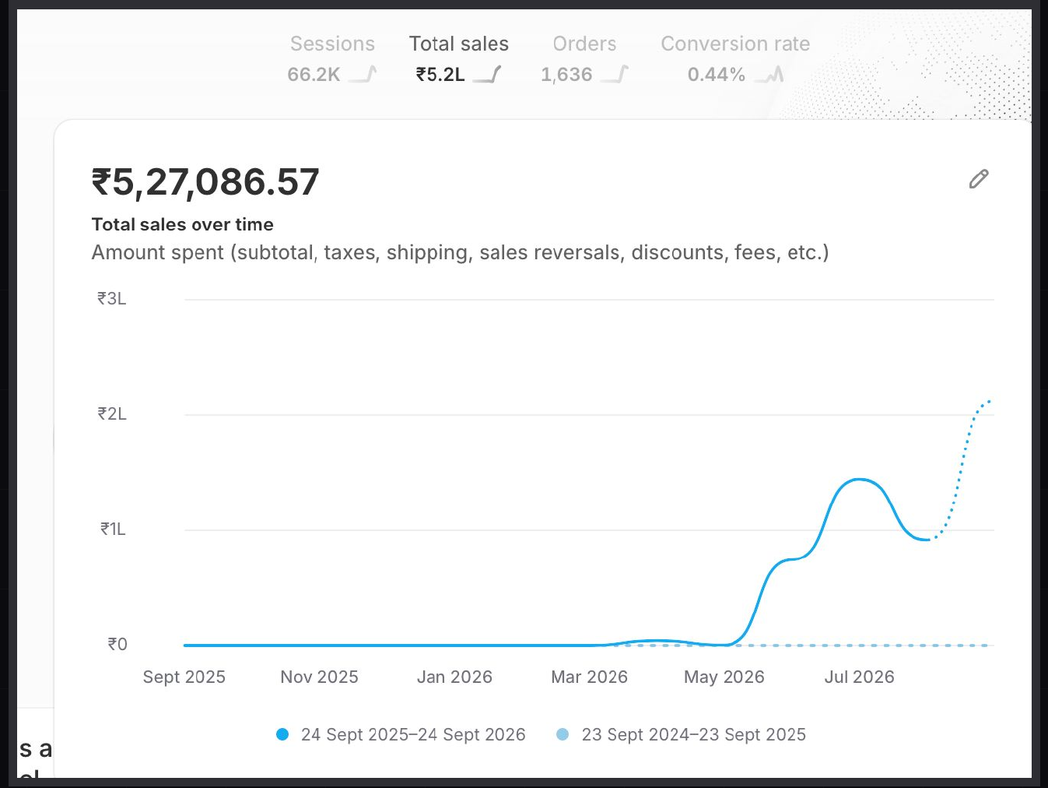
Figure 1. Shopify sales dashboard screenshot - original source image.

7. Results & Outcomes
The store recorded ₹5.27 L in total sales, 66.2K sessions and 1,636 orders. Based on the rounded figures, the simple sales-per-order ratio is approximately ₹322 and orders per 100 sessions are about 2.47. These are derived calculations, not official Shopify average order value or conversion-rate figures. The trend description adds that sales started in late spring 2026, grew through summer and continued upwards into the following month.
The dashboard total was ₹5.27 lakh in sales, with 66.2K sessions and 1,636 orders. The timeline shows the sales line beginning in late spring and continuing upwards through the summer and the following month.

What stands out in the result
The case shows an early store with reported sales and order volume, followed by an upward trend through the next period. It is evidence of momentum, but the available record does not show whether the trend continued after the period displayed.

8. Key Learnings
- Early order volume can provide a useful base for reviewing products, customer behaviour and the next growth decision.
- The sales curve provides context that the ₹5.27 lakh total alone cannot show.
- A store-level result should not be presented as an advertising result when the source does not disclose ad spend or attribution.

BUSINESS VALUE AND CLOSE

9. Business Impact
The store recorded ₹5.27 lakh in sales, 66.2K sessions and 1,636 orders. The sales line began in late spring 2026 and continued to rise through summer and into the following month. The order count adds useful context to the size of the store's activity.
For the business, this provides early evidence to study product demand and customer activity. It does not show whether the store was profitable or which channel delivered the orders, because spend and margin information are not part of the source.

Business decisions this case can inform
Decision area | What the case suggests | What should be checked next
Momentum review | Track the continued upward sales line. | Month-by-month revenue values.
Order operations | Use 1,636 orders as the transaction-volume context. | Delivery, returns and support capacity.
Acquisition | Do not assume a specific campaign drove the trend. | Ad spend and source-of-order reporting.

10. Conclusion
This Shopify case records ₹5.27 lakh in sales, 66.2K sessions and 1,636 orders. Sales began in late spring 2026 and continued to climb through summer and the following month. It shows early store momentum, while campaign-level causes and profit remain outside the information supplied.

Publishing accuracy note
The source does not identify the store or category and does not provide advertising spend, ROAS, marketing channels, campaign changes, month-by-month totals, gross margin or repeat-purchase data. Sales-per-order and orders-per-session are approximate calculations from rounded figures, not official Shopify metrics. No claim about profit or a specific marketing driver is made.

