CASE STUDY 14 | SEE ALL LIBRARY
Shopify Store C
A new revenue line reached ₹9.72 lakh in the tracked period

1. Case Study Overview
This case follows a Shopify store whose sales were close to zero for much of the tracked period before rising sharply in early summer 2026. The store recorded ₹9.72 L in total sales, 1.0 L sessions and 1,475 orders. The source notes that one month crossed ₹4 L in sales.
The source describes this as a brand-new revenue line. The sales chart shows little activity for much of the tracked period, followed by a sharp increase in early summer 2026. The store’s name, product category and launch details are not included. The case therefore focuses on the sales curve and the totals shown in Shopify rather than filling in missing information about the product or launch plan.

Performance snapshot from the original case record
Metric | Reported figure
Total sales | ₹9.72 L
Sessions | 1.0 L
Orders | 1,475
Observed trend | Sales were near zero until early summer 2026
Peak month noted | More than ₹4 L

BUSINESS CONTEXT

2. The Challenge
The visible challenge was to move from an almost inactive sales line to meaningful order and revenue volume. The source says sales were essentially nil until early summer 2026, then rose to more than ₹4 L in a single month. It does not explain the exact date the store went live, the marketing activity behind the change or whether the jump came from a launch, a campaign, a seasonal event or another factor.
The main challenge visible in the chart was the move from almost no sales to a meaningful revenue month. For a new revenue line, the first stage is to create enough customer activity for the store to record orders and revenue. The source does not provide the launch date or the exact reasons for the change.

What made this case difficult
The chart shows the sharp change, but it does not give exact monthly figures or the launch date. The claim should therefore remain that one month crossed ₹4 lakh in early summer 2026, rather than stating an exact number of days to reach that level.

Practical effect on the business
For a new store, an early period with almost no sales can make it difficult to judge traction. The sharp rise in early summer gives a visible milestone, but further detail is needed to understand the launch process and whether the result was sustainable.

3. Objective
The source does not provide a formal launch target or a pre-defined revenue goal. The documented outcome is the store’s reported performance: ₹9.72 L in total sales, 1.0 L sessions and 1,475 orders, alongside a sharp upward movement in early summer 2026.
No formal target is stated. The case records the store's sales total and the movement from a near-zero sales line to a month above ₹4 lakh. The exact launch objective and the date the store began trading are not supplied.

Objective and available success measures
Objective area | Evidence available in the source
Store revenue | ₹9.72 L total sales
Store traffic | 1.0 L sessions
Order volume | 1,475 orders
Growth trend | One month crossed ₹4 L in early summer 2026

APPROACH AND DELIVERY

4. Strategy
The source presents this as a new revenue line that moved from almost no sales to a meaningful monthly result in early summer 2026. Its written takeaway refers to getting the offer, creative and targeting in place from the start. However, the source does not provide the exact offer, ad formats, audience setup or launch plan.
The supported strategy story is therefore the change in the store's sales pattern, not a list of campaign tactics. The sharp rise is visible in the Shopify chart, but the available information does not allow the increase to be attributed to one specific campaign or marketing decision.

How the strategy addressed the business need
The available material supports a story about a new revenue line gaining traction. It does not support a detailed explanation of channel strategy, creative choices or targeting settings.

Why this structure fits the case
The written source takeaway mentions offer, creative and targeting as important parts of a new store setup. These are general elements of the setup described by the original case, but individual details are not supplied. The case should not add specific product offers or campaign formats that are not visible in the material.

5. Campaign Execution
The dashboard evidence shows a largely flat sales line until early summer 2026, followed by a rapid rise. The source’s takeaway is that a new store can reach meaningful revenue when the offer, creative and targeting are set up properly from day one. However, the exact offer, creative, target audience, advertising channel, budget and launch date are not stated. This document therefore records the growth pattern without assigning it to specific tactics that are not present in the source. If the team later confirms the launch plan or advertising breakdown, those details can be added as a verified execution section.

Documented sales timeline
Period / stage | What the original case record shows
Before early summer 2026 | Sales were essentially at zero or close to it.
Early summer 2026 | The sales line rose sharply.
Peak month shown | One month recorded more than ₹4 lakh in sales.

The source does not give a launch plan, creative examples, targeting details, advertising spend or exact launch date. The timeline table records only the sales movement visible in the case record.
The source shows the store's sales line staying close to zero before early summer 2026 and then moving sharply upwards. The written takeaway refers to the offer, creative and targeting being set up from day one, but no exact offer or campaign details are included. This case can describe the sales movement, while the launch method should only be expanded if supporting records are available.

NUMBERS AND REPORTING

6. Performance Analysis

Reading the main metrics
The dashboard records ₹9.72 lakh in total sales, 1 lakh sessions and 1,475 orders. The curve is described as near zero until early summer 2026, when one month rose above ₹4 lakh. The total is a store-sales figure. It is not an ad-attributed revenue figure because the source does not provide ad spend or channel attribution.
The 1 lakh sessions and 1,475 orders give context to the ₹9.72 lakh sales total. The chart's sharp rise is the defining pattern, with one month above ₹4 lakh. The source does not report traffic channels or advertising cost, so the data cannot show how much each visitor source contributed or whether the store achieved a profitable acquisition cost.

What the figures do and do not show
The source does not state the exact store launch date, product category, advertising spend, gross margin or channel attribution. Do not claim a precise number of weeks to reach the sales result.
Metric | Reported figure
Total sales | ₹9.72 L
Sessions | 1.0 L
Orders | 1,475
Observed trend | Sales were near zero until early summer 2026
Peak month noted | More than ₹4 L

Original Dashboard Evidence
The following images are the original screenshots supplied in the source case-study document. They are included as visual supporting evidence and have not been altered.
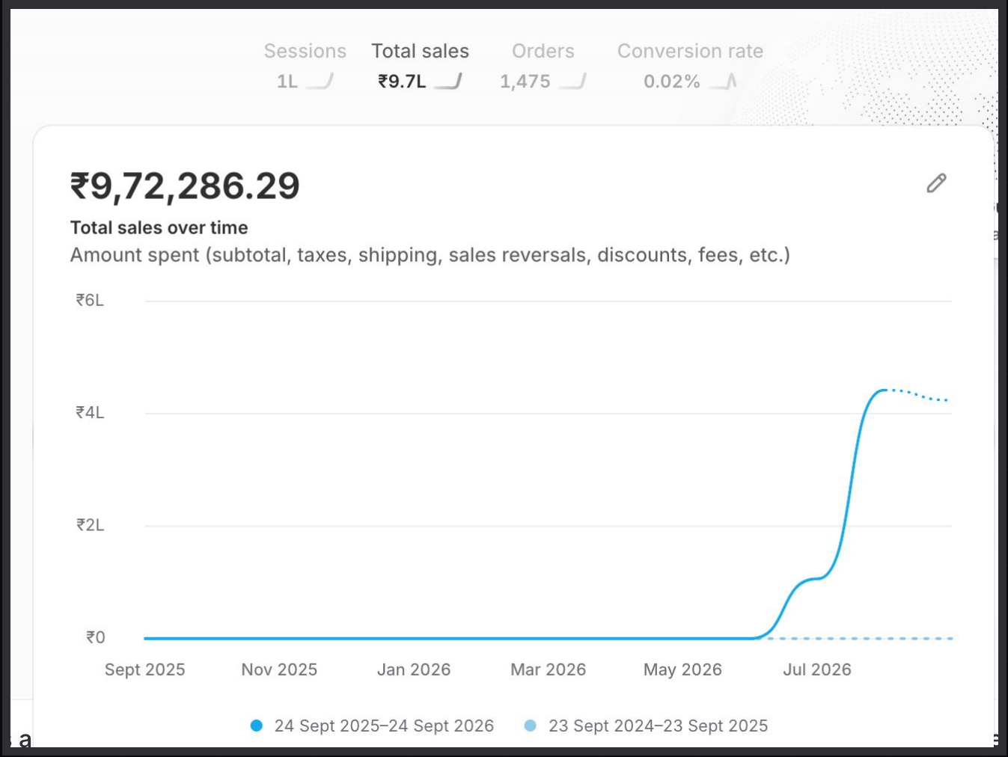
Figure 1. Shopify sales dashboard screenshot - original source image.

7. Results & Outcomes
The store recorded ₹9.72 L in total sales, 1.0 L sessions and 1,475 orders. Based on the rounded figures, sales per order were approximately ₹659 and orders per 100 sessions were about 1.48. These are derived ratios for context, not official Shopify AOV or conversion-rate metrics. The most distinctive part of the result is the sales curve: little reported sales activity until early summer 2026, followed by a month with more than ₹4 L in sales.
The dashboard total was ₹9.72 lakh in sales, with 1 lakh sessions and 1,475 orders. The sharp rise in early summer 2026 is the clearest outcome, with one month crossing ₹4 lakh after a period of almost no recorded sales.

What stands out in the result
The result is the movement from a near-zero sales line to a month above ₹4 lakh. This is more informative than quoting the final total alone, because it shows the point at which the new revenue line became meaningful.

8. Key Learnings
- For a new revenue line, the movement from near-zero sales to a month above ₹4 lakh is an important milestone.
- Use total sales, sessions and orders together rather than relying on one headline number.
- Confirm launch dates and campaign records before making a precise claim about how quickly the result was achieved or which tactic drove it.

BUSINESS VALUE AND CLOSE

9. Business Impact
The store recorded ₹9.72 lakh in total sales, 1 lakh sessions and 1,475 orders. The sales chart is the strongest part of the story: the line was close to zero until early summer 2026 and then rose sharply, with one month crossing ₹4 lakh.
The result shows a new revenue line reaching measurable scale during the tracked period. The source does not include margin, acquisition cost or the launch plan, so the commercial impact cannot be taken further than the reported store sales, traffic and order totals.

Business decisions this case can inform
Decision area | What the case suggests | What should be checked next
Launch review | Study the move from near-zero sales to a month above ₹4 L. | Exact launch date and monthly revenue.
Offer and product | Review the offer, product mix and sales pattern. | Offer details, margins and refunds.
Acquisition | Traffic and order totals show store activity. | Channel split and customer acquisition cost.

10. Conclusion
This Shopify case records ₹9.72 lakh in sales, 1 lakh sessions and 1,475 orders. The chart shows a sharp shift from almost no sales to a month above ₹4 lakh in early summer 2026. The store result is clear, but the source does not provide the launch date or campaign details needed to explain the exact cause or speed of growth.

Publishing accuracy note
The source does not state the store name, product category, exact launch date, traffic sources, advertising spend, ROAS, profit, margin or month-by-month sales table. The derived ratios use rounded totals and are not official platform metrics. Do not claim that the store reached ₹9.72 L within a specified number of weeks unless the exact start date is confirmed.

