CASE STUDY 13 | SEE ALL LIBRARY
Shopify Store B
₹29.72 lakh in total sales across 3.4 lakh sessions

1. Case Study Overview
This Shopify store recorded ₹29.72 L in total sales, 3.4 L sessions and 2,250 orders. The source describes growth beginning in the early months of the tracked year and accelerating from spring, with monthly sales moving towards a peak of approximately ₹6–7 L.
The case is documented through a Shopify sales dashboard and a short description of the store’s revenue trend. Unlike the campaign-focused cases, the source does not identify the product category, paid-media structure or specific marketing changes. It records the store’s sales, sessions and order volume, along with a trend that strengthened as the tracked period progressed.

Performance snapshot from the original case record
Metric | Reported figure
Total sales | ₹29.72 L
Sessions | 3.4 L
Orders | 2,250
Observed trend | Growth accelerated from spring
Peak monthly sales | Approximately ₹6–7 L

BUSINESS CONTEXT

2. The Challenge
The story presented by the source is about building momentum over time. Sales began growing in the early months of the tracked year and accelerated from spring. The useful question is not only how much the store sold in total, but how the monthly performance changed. The available material does not state what operational or marketing actions caused each step in that trend.
The store needed to turn early growth into a stronger and more consistent sales pattern. The chart shows that growth accelerated from spring and monthly sales moved towards ₹6-7 lakh. The source does not identify the exact operational or marketing challenges that existed before this acceleration.

What made this case difficult
The source provides three store-level measures and a broad monthly trend. It does not include the month's exact revenue values, so the ₹6-7 lakh peak remains an approximate figure as stated in the original case.

Practical effect on the business
A single total can make a store look static. The sales curve provides a better view of when the business began to accelerate. The source does not include enough detail to explain what changed operationally at the point growth began.

3. Objective
No formal campaign target or business brief is included. The case is therefore framed around the reported store outcome and the pattern of growth: ₹29.72 L in sales, 3.4 L sessions and 2,250 orders, with monthly sales climbing towards ₹6–7 L at the peak.
No formal campaign or revenue target is included. The case records the store's sales total, sessions, orders and the increase in monthly sales from spring. These are the outcomes that can be presented accurately from the available material.

Objective and available success measures
Objective area | Evidence available in the source
Store revenue | ₹29.72 L total sales
Store traffic | 3.4 L sessions
Order volume | 2,250 orders
Growth trend | Monthly sales accelerated from spring towards ₹6-7 L

APPROACH AND DELIVERY

4. Strategy
The strategy detail available in the source is the sales trend itself. The store began growing in the early part of the tracked year, then accelerated from spring, with monthly sales reaching approximately ₹6-7 lakh at the peak. The source does not name the marketing channels or the actions taken at each point.
A complete campaign strategy cannot be reconstructed from a sales chart alone. The most accurate way to use this case is to show the increase in store sales and explain how the trend developed over the tracked period. Any specific claim about Meta Ads, creative testing, targeting or budget changes would need separate campaign records.

How the strategy addressed the business need
The strongest strategy insight available is to track the sales curve over time. The chart indicates acceleration from spring, but cannot identify which marketing action caused each movement.

Why this structure fits the case
The sales chart is useful as a growth record, but it is not a record of the actions behind the growth. A detailed strategy description would need channel data, campaign activity and monthly sales by source. Until that material is available, the strategy section stays focused on the visible growth progression and the limits of the record.

5. Campaign Execution
The source does not list campaign types, audiences, creative or budget decisions for this store. What it does show is a growing sales line during the tracked year. Growth began in the earlier months, then accelerated from spring, and monthly sales rose towards ₹6–7 L at the peak. This makes the case a store-performance story rather than a campaign execution breakdown. Any explanation of specific ad tactics, product launches, discounting, website changes or retention activity would need to be confirmed from other records before it is added.

Documented sales timeline
Period / stage | What the original case record shows
Early part of tracked year | Sales growth had begun.
From spring 2026 | The growth rate accelerated.
Peak period shown | Monthly sales reached approximately ₹6-7 lakh.

The source provides a sales chart, not a campaign report. Campaign names, spend, targeting, creative, channel mix and website changes are not documented.
The original record shows the sales curve beginning to rise in the early months and accelerating from spring. The monthly line moved towards ₹6-7 lakh at the peak. Since there is no campaign report, the practical execution evidence is limited to the progression visible in the store dashboard rather than specific advertising tasks.

NUMBERS AND REPORTING

6. Performance Analysis

Reading the main metrics
The Shopify dashboard records ₹29.72 lakh in total sales, 3.4 lakh sessions and 2,250 orders. The accompanying description says the sales curve accelerated from spring and reached approximately ₹6-7 lakh in a peak month. The figures describe store activity, not paid advertising performance. No ad-spend or ROAS measure is included.
The 3.4 lakh sessions indicate the amount of store traffic recorded during the period, while 2,250 orders show the recorded order volume. The sales total was ₹29.72 lakh. The trend chart adds that the monthly sales pace increased from spring and reached approximately ₹6-7 lakh at its strongest point. Since exact monthly data is not given, month-on-month growth rates should not be calculated.

What the figures do and do not show
The source does not identify the store category, advertising spend, marketing channels, gross margin or repeat-purchase rate. The peak monthly sales figure is approximate as described in the original case.
Metric | Reported figure
Total sales | ₹29.72 L
Sessions | 3.4 L
Orders | 2,250
Observed trend | Growth accelerated from spring
Peak monthly sales | Approximately ₹6–7 L

Original Dashboard Evidence
The following images are the original screenshots supplied in the source case-study document. They are included as visual supporting evidence and have not been altered.
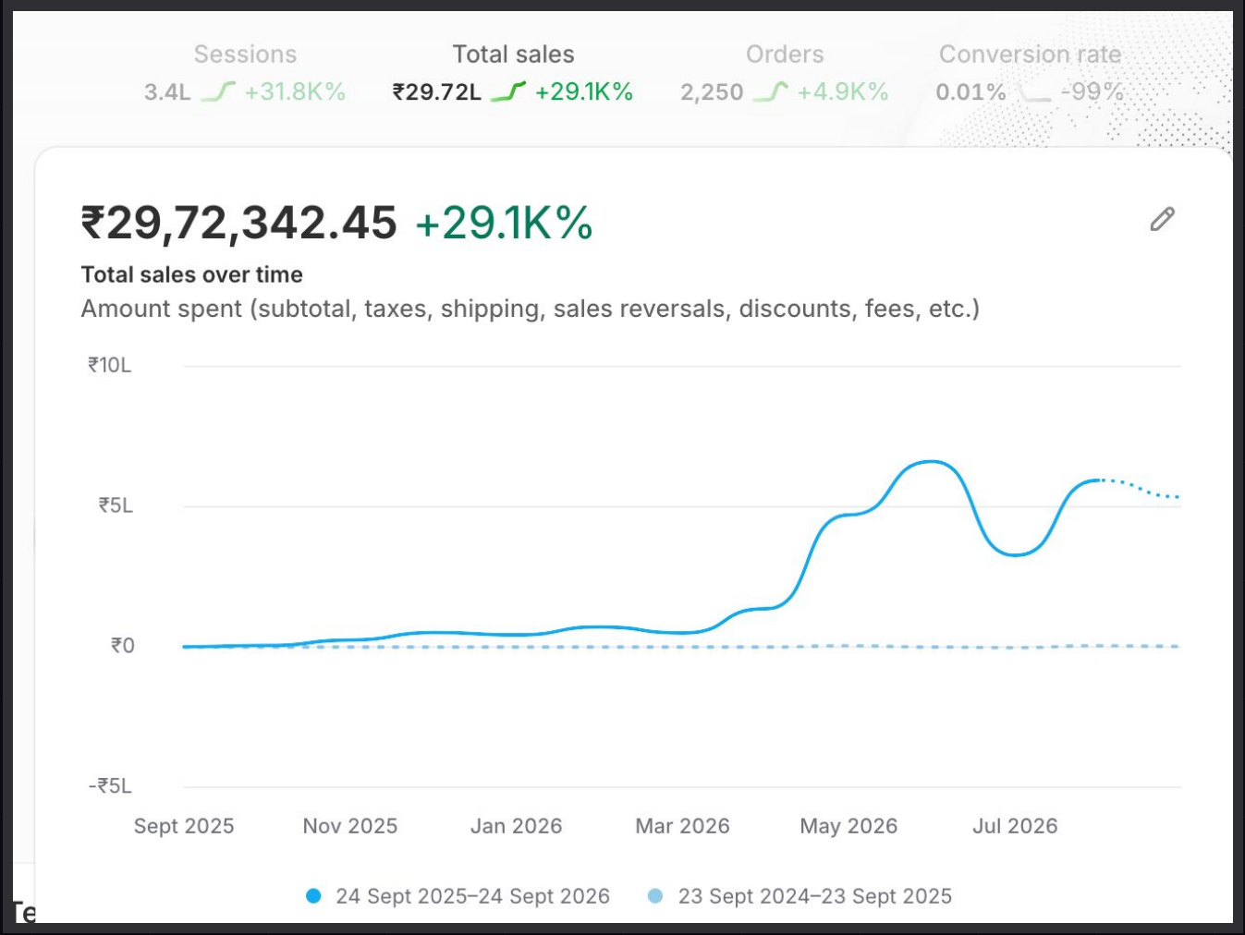
Figure 1. Shopify sales dashboard screenshot - original source image.

7. Results & Outcomes
The store reported ₹29.72 L in total sales, 3.4 L sessions and 2,250 orders. Dividing the rounded sales figure by the order count gives a simple sales-per-order ratio of approximately ₹1,321. Dividing orders by sessions gives about 0.66 orders per 100 sessions. These are arithmetic ratios based on the rounded snapshot, not official Shopify AOV or conversion-rate fields. The source describes monthly sales rising towards ₹6–7 L at the peak, but does not provide the exact value for each month.
The dashboard total was ₹29.72 lakh in sales, with 3.4 lakh sessions and 2,250 orders. The sales curve began moving earlier in the tracked year and accelerated from spring, reaching approximately ₹6-7 lakh in the strongest month.

What stands out in the result
The store's sales total is supported by a substantial session count and 2,250 orders. The growth curve adds the important context that sales accelerated from spring rather than staying at the same pace throughout the tracked period.

8. Key Learnings
- Track the shape of growth over time. The increase from spring and the ₹6-7 lakh monthly peak are part of the story, not just the ₹29.72 lakh total.
- Read sales together with sessions and orders to understand the store activity behind the total.
- A revenue chart does not identify which campaign, channel or creative caused each increase.

BUSINESS VALUE AND CLOSE

9. Business Impact
The store recorded ₹29.72 lakh in total sales, 3.4 lakh sessions and 2,250 orders. The chart adds a clear growth pattern: sales began increasing in the early tracked months and accelerated from spring, reaching approximately ₹6-7 lakh in a peak month.
For the business, this provides a view of how traffic and orders developed alongside revenue. It does not identify the exact activity behind each change or disclose profit, ad spend or repeat sales.

Business decisions this case can inform
Decision area | What the case suggests | What should be checked next
Growth timing | Review the acceleration from spring. | Exact monthly sales table.
Traffic and orders | Use sessions and orders alongside sales. | Traffic source, product mix and repeat customers.
Marketing attribution | Do not attribute the chart to one channel without evidence. | Campaign logs and channel-level revenue.

10. Conclusion
This Shopify case records ₹29.72 lakh in sales, 3.4 lakh sessions and 2,250 orders. The sales curve accelerated from spring and reached approximately ₹6-7 lakh in a peak month. It is a useful record of store growth over time, while the marketing activity behind the curve remains unspecified in the source.

Publishing accuracy note
The source does not identify the brand, store category, advertising spend, ROAS, marketing channels, campaign tactics, gross margin, product price or exact monthly sales values. The sales-per-order and orders-per-session calculations are derived from rounded totals and are not official platform metrics. Avoid claiming a specific campaign caused the increase unless separate evidence is available.

