CASE STUDY 12 | SEE ALL LIBRARY
Shopify Store A
₹43.05 lakh in total sales with 3.8 lakh sessions

1. Case Study Overview
This Shopify store moved from a period of relatively flat sales to a stronger growth curve during the tracked year. The source reports ₹43.05 L in total sales, 3.8 L sessions and 10.2K orders. It describes sales stepping up after spring 2026 and approaching ₹15 L in a single month during the summer.
The source presents this case through a Shopify sales dashboard rather than a detailed campaign narrative. It says sales were close to flat until spring 2026. After the paid-social activity was switched on, monthly revenue stepped up through the summer. The brand name, product category, price range and operating model are not supplied, so the case is kept anonymous and focused on the store results shown.

Performance snapshot from the original case record
Metric | Reported figure
Total sales | ₹43.05 L
Sessions | 3.8 L
Orders | 10.2K
Observed trend | Sales rose from spring 2026 through summer
Peak month noted | Approached ₹15 L

BUSINESS CONTEXT

2. The Challenge
The observable business challenge was to move the store beyond a relatively flat sales period and create stronger monthly sales momentum. The source links the timing of the growth curve with the paid-social system being switched on. It does not provide a campaign-by-campaign breakdown or a full attribution report, so the document does not claim that every rupee of Shopify sales came directly from paid social.
The store's sales line was close to flat before the spring 2026 period. The challenge described in the source was to change that pattern and build a more active sales channel. The dashboard makes the timing of the change visible, even though it does not explain every action taken behind it.

What made this case difficult
The source provides a total-sales figure, sessions, orders and a curve that approaches ₹15 lakh in one month. It does not provide a monthly table or traffic-source breakdown. The available evidence is enough to explain the sales movement, but not to quantify the contribution of every channel.

Practical effect on the business
A flat sales line gives the business little evidence of growth momentum. The later increase is visible, but without a month-by-month source table it is difficult to see exactly when each rise occurred or which channel contributed to it.

3. Objective
The source does not state a formal target, pre-launch forecast or campaign brief. The documented outcome is a store-level growth result: ₹43.05 L in total sales, 3.8 L sessions and 10.2K orders, with the monthly trend rising after spring 2026. The objective is therefore described as the observable growth outcome rather than a target that was not included in the source.
The source does not state a formal target. The result being documented is the rise in store sales during the tracked period, together with the number of sessions and orders. The source says the paid-social ad engine was switched on before the sales increase, but does not provide an agreed target or attribution breakdown.

Objective and available success measures
Objective area | Evidence available in the source
Store revenue | ₹43.05 L total sales
Store traffic | 3.8 L sessions
Order volume | 10.2K orders
Growth trend | Monthly sales rose after spring 2026 and approached ₹15 L

APPROACH AND DELIVERY

4. Strategy
The source connects the change in the store's sales curve with the point when the paid-social ad engine was switched on. The sales line was close to flat before spring 2026 and rose through the summer afterwards. This supports a story about a change in store performance during the tracked period.
The original material does not provide a campaign plan, audience structure, creative examples, ad spend or channel-by-channel attribution. For that reason, this case should be presented as a Shopify sales-growth result associated in the source with paid-social activity, rather than as a detailed campaign playbook.

How the strategy addressed the business need
The documented sequence is a store-level change in sales over time. It can be used to show the timing and scale of growth, but the original material does not contain enough detail to describe individual campaign decisions.

Why this structure fits the case
The source gives one clear timing point: paid social was switched on before the sales curve moved upwards. That is an important part of the case narrative, but it is not enough to reconstruct the full marketing plan. The sales pattern should be paired with campaign records before writing about specific audiences, offers or creative decisions.

5. Campaign Execution
The clearest execution detail in the source is that a paid-social system was switched on after a period when sales were close to flat. The dashboard trend then shows monthly sales stepping up through spring and summer 2026, approaching ₹15 L in a single month. No campaign structure, audience targeting, creative concepts, spend, budget split or optimisation steps are documented for this store. Those details should not be added to the website copy unless the team can confirm them from the ad account. The value of the case is the visible change in the store’s sales trend and the scale of the reported sessions and orders.

Documented sales timeline
Period / stage | What the original case record shows
Before spring 2026 | Sales were close to flat in the chart.
After paid social was switched on | Monthly sales stepped up through the summer.
Peak period shown | Monthly revenue approached ₹15 lakh in a single month.

No campaign list, audience setup, creative examples, budget breakdown or monthly ad-spend data is included. The page should be described as a Shopify store growth case, with paid-social timing noted as stated in the source.
The source's execution evidence is the change in the Shopify sales line after paid social was switched on. Monthly sales were close to flat before spring 2026 and rose through the summer, approaching ₹15 lakh in one month. No separate list of campaigns or optimisations is included, so this section should not add claims about audiences, creatives or budget changes.

NUMBERS AND REPORTING

6. Performance Analysis

Reading the main metrics
The Shopify snapshot records ₹43.05 lakh in total sales, 3.8 lakh sessions and 10.2K orders. The sales chart shows a near-flat period before spring 2026 and a rise through the summer, approaching ₹15 lakh in one month. These are store-level measures. The source does not supply ad spend or ROAS, so paid-media efficiency cannot be calculated from this case.
The sales total is spread across 3.8 lakh sessions and 10.2K orders. The sales curve is also important: it indicates a near-flat starting period followed by a sharp step-up after spring 2026. The source mentions that the paid-social ad engine was switched on, but it does not provide ad spend, ROAS or a channel report. The result can therefore be described through Shopify sales, traffic and orders, not cost efficiency.

What the figures do and do not show
The source does not provide advertising spend, gross margin, refunds, repeat purchases or channel-level sales attribution. The reported ₹43.05 lakh is Shopify total sales, not an independently verified paid-ad revenue figure.
Metric | Reported figure
Total sales | ₹43.05 L
Sessions | 3.8 L
Orders | 10.2K
Observed trend | Sales rose from spring 2026 through summer
Peak month noted | Approached ₹15 L

Original Dashboard Evidence
The following images are the original screenshots supplied in the source case-study document. They are included as visual supporting evidence and have not been altered.
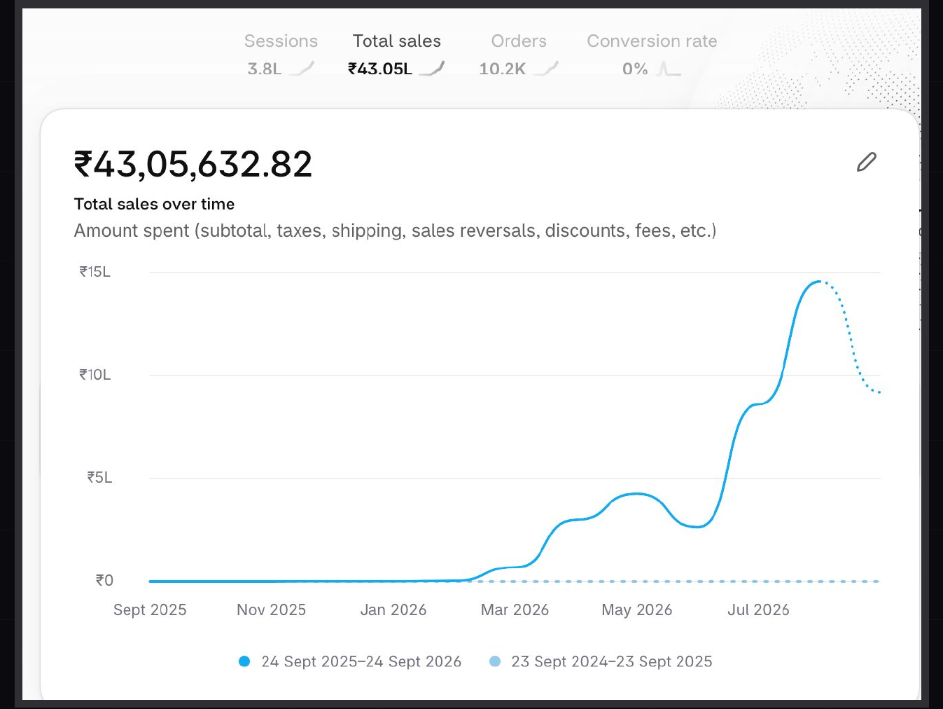
Figure 1. Shopify sales dashboard screenshot - original source image.

7. Results & Outcomes
The Shopify snapshot reports ₹43.05 L in total sales, 3.8 L sessions and 10.2K orders. A simple calculation using the rounded snapshot figures gives approximately ₹422 in sales per order and around 2.68 orders per 100 sessions. These are derived ratios, not platform-reported average order value or conversion rate. The chart narrative says sales were close to flat until spring 2026, then increased through summer and approached ₹15 L in one month. The source does not provide monthly figures for every point, so the trend is described rather than reconstructed into a precise monthly series.
The dashboard total was ₹43.05 lakh in sales, supported by 3.8 lakh sessions and 10.2K orders. The chart adds the timing: after a relatively flat period, monthly sales rose through spring and summer and approached ₹15 lakh in one month.

What stands out in the result
The result is a clear upward shift in store sales during the tracked year. The final total gives the scale, while the sales chart shows when the step-up became visible. The source links the timing to paid social being switched on, but does not provide attribution details.

8. Key Learnings
- A sales timeline can show when store performance changed, not only the final total.
- Sessions and orders add context to revenue. Together, they help a reader understand the scale of store activity.
- The source associates the step-up with paid-social being switched on, but does not provide the campaign details needed to isolate the contribution of each activity.

BUSINESS VALUE AND CLOSE

9. Business Impact
The Shopify dashboard recorded ₹43.05 lakh in sales, 3.8 lakh sessions and 10.2K orders. The timeline is useful because it shows the change in monthly sales after the spring 2026 period, with revenue approaching ₹15 lakh in a single month. The source states that the ad engine was switched on before the increase.
These figures show store-level performance, not profit. The source does not provide the advertising spend, contribution margin or channel attribution needed to calculate the return from paid social alone.

Business decisions this case can inform
Decision area | What the case suggests | What should be checked next
Growth review | Study the step-up after spring 2026. | Monthly sales and traffic-source breakdown.
Store operations | Use 10.2K orders as the workload context. | Fulfilment, returns and repeat orders.
Paid media | Source notes paid social was switched on. | Ad spend, attribution and paid-social ROAS.

10. Conclusion
This Shopify case records ₹43.05 lakh in sales, 3.8 lakh sessions and 10.2K orders. The sales chart shows a clear rise after spring 2026, following the point when the source says the paid-social ad engine was switched on. The available material supports a store-growth story, not a full account-level breakdown of ad performance.

Publishing accuracy note
The source does not disclose the store category, brand name, exact campaign dates, advertising spend, ROAS, product mix, gross margin or channel attribution. The sales-per-order and orders-per-session figures in this document are simple calculations from rounded totals and should not be labelled as official AOV or conversion rate. Total Shopify sales should not be represented as fully ad-attributed revenue.

