CASE STUDY 11 | SEE ALL LIBRARY
Brand Awareness Test
70,800 ad-recall lifts at a reported ₹0.05 per lift

1. Case Study Overview
A brand wanted to build memory before asking people to make a purchase. ScaleXpertz ran an upper-funnel campaign optimised for ad recall rather than clicks, using short, memorable creative. The campaign recorded 70,800 ad-recall lifts at a reported ₹0.05 per lift, with total spend of about ₹4,801.
The case focused on awareness rather than immediate sales. The source states that the brand wanted to be remembered before it asked for a sale. That changes how the campaign should be evaluated: the primary reported result is ad recall, not purchases, website sessions or revenue.

Performance snapshot from the original case record
Metric | Reported figure
Ad-recall lifts | 70,800
Reported cost per lift | ₹0.05
Total spend | About ₹4,801
Strong ad set | 33,000 lifts at ₹0.05 each
Campaign objective | Ad recall / awareness

BUSINESS CONTEXT

2. The Challenge
A brand-awareness campaign can be misread if it is judged only by click or purchase metrics. The account needed an objective aligned with the job it was meant to perform: helping people remember the brand. The source describes short, memorable creative and an upper-funnel optimisation approach, but it does not provide the creative itself or the audience breakdown.
The brand wanted people to remember it before asking them to buy. A click-focused campaign would not directly measure that goal. The challenge was to use an awareness objective and assess it through ad-recall lifts rather than judge it by purchase numbers.

What made this case difficult
A recall lift is an awareness measurement. It does not mean a person clicked, visited the website or made a purchase. The challenge was therefore to judge the campaign by the metric linked to its actual objective.

Practical effect on the business
An awareness campaign can look weak if it is judged only by website clicks. The goal was recall, so the account needed a measure that reflected whether the audience remembered the ad. The source does not provide a later conversion view, which means the immediate awareness result is the focus.

3. Objective
The campaign was optimised for ad recall rather than clicks. Its purpose was to build memory at a low reported cost per recall lift. No purchase target, sales target or conversion objective is stated in the source, so this case should be presented as an awareness test rather than a sales case.
The objective was to measure whether short, memorable creative could increase ad recall at a low cost. The campaign was not described as a purchase campaign, so purchase or ROAS targets are not relevant to the result supplied.

Objective and available success measures
Objective area | Evidence available in the source
Awareness objective | Ad recall rather than clicks or purchases
Recall volume | 70,800 ad-recall lifts
Reported unit cost | ₹0.05 per lift in the written summary
Spend context | Approximately ₹4,801 reported total spend

APPROACH AND DELIVERY

4. Strategy
The strategy was an upper-funnel awareness test. Instead of optimising for website clicks or purchases, the campaign was set up around ad recall. The creative was described as short and memorable, which fits the aim of helping people remember the brand before they are asked to buy.
The main measure was cost per ad-recall lift. This is different from CPC, cost per purchase or ROAS. The test is therefore judged by how many recall lifts were recorded for the spend, not by sales that the source does not report.

How the strategy addressed the business need
The chosen measurement matched the purpose of the campaign. Ad recall was the central result, so the awareness test is not judged by clicks or purchases.

Why this structure fits the case
The selected objective matches the brand's stated need to be remembered before asking for a sale. This is why the result is expressed as recall lifts and cost per lift. It gives the awareness activity its own scorecard and avoids judging it by outcomes it was not designed to optimise for.

5. Campaign Execution
ScaleXpertz ran an upper-funnel test using short, memorable creative and optimised the campaign for ad recall instead of click volume. One ad set delivered 33,000 recall lifts at a reported ₹0.05 each. The full campaign delivered 70,800 recall lifts. This approach aligns the campaign objective with the outcome the brand wanted: to be remembered before a later sales message. The source does not specify creative duration, message, frequency, reach, audience, brand-lift survey method or how the campaign was connected to later conversion activity.

Campaign or activity breakdown
Campaign / activity | Role in the account | Reported evidence
Upper-funnel ad-recall test | Optimise for recall rather than clicks | 70,800 ad-recall lifts
Short, memorable creative | Use creative suited to a memory objective | ₹0.05 reported cost per lift
Strongest named ad set | Show one ad-set result separately | 33,000 lifts at ₹0.05 each

The source identifies short, memorable creative and an ad-recall objective. It does not show the creative files, audience demographics, frequency or later conversion results.
The campaign was set to optimise for ad recall, and the source describes the creative as short and memorable. The strongest named ad set delivered 33,000 recall lifts at ₹0.05 each. The total account view reported 70,800 lifts and approximately ₹4,801 in spend. The written per-lift figure and total spend do not reconcile exactly when divided, so the discrepancy should be checked before using both as a single calculated claim.

NUMBERS AND REPORTING

6. Performance Analysis

Reading the main metrics
The campaign recorded 70,800 ad-recall lifts at a reported ₹0.05 per lift, with total spend of about ₹4,801. One ad set delivered 33,000 lifts at ₹0.05 each. The source's summary says under ₹4,801, while the screenshot total is ₹4,801.02; the safest wording is approximately ₹4,801. The measure is awareness, not sales.
The dashboard includes an important reporting detail: the text reports ₹0.05 per recall lift and 70,800 lifts, while the screenshot shows total spend of ₹4,801.02. Dividing the spend by 70,800 gives approximately ₹0.068 per lift, not ₹0.05. The source may be using different reporting subsets or rounding, but it does not explain the difference. The total lift count and stated unit cost should be verified before publication as a combined calculation.

What the figures do and do not show
The source does not show sales, store visits or later conversions from people who saw the ads. The result supports an awareness claim only.
Metric | Reported figure
Ad-recall lifts | 70,800
Reported cost per lift | ₹0.05
Total spend | About ₹4,801
Strong ad set | 33,000 lifts at ₹0.05 each
Campaign objective | Ad recall / awareness

Original Dashboard Evidence
The following images are the original screenshots supplied in the source case-study document. They are included as visual supporting evidence and have not been altered.
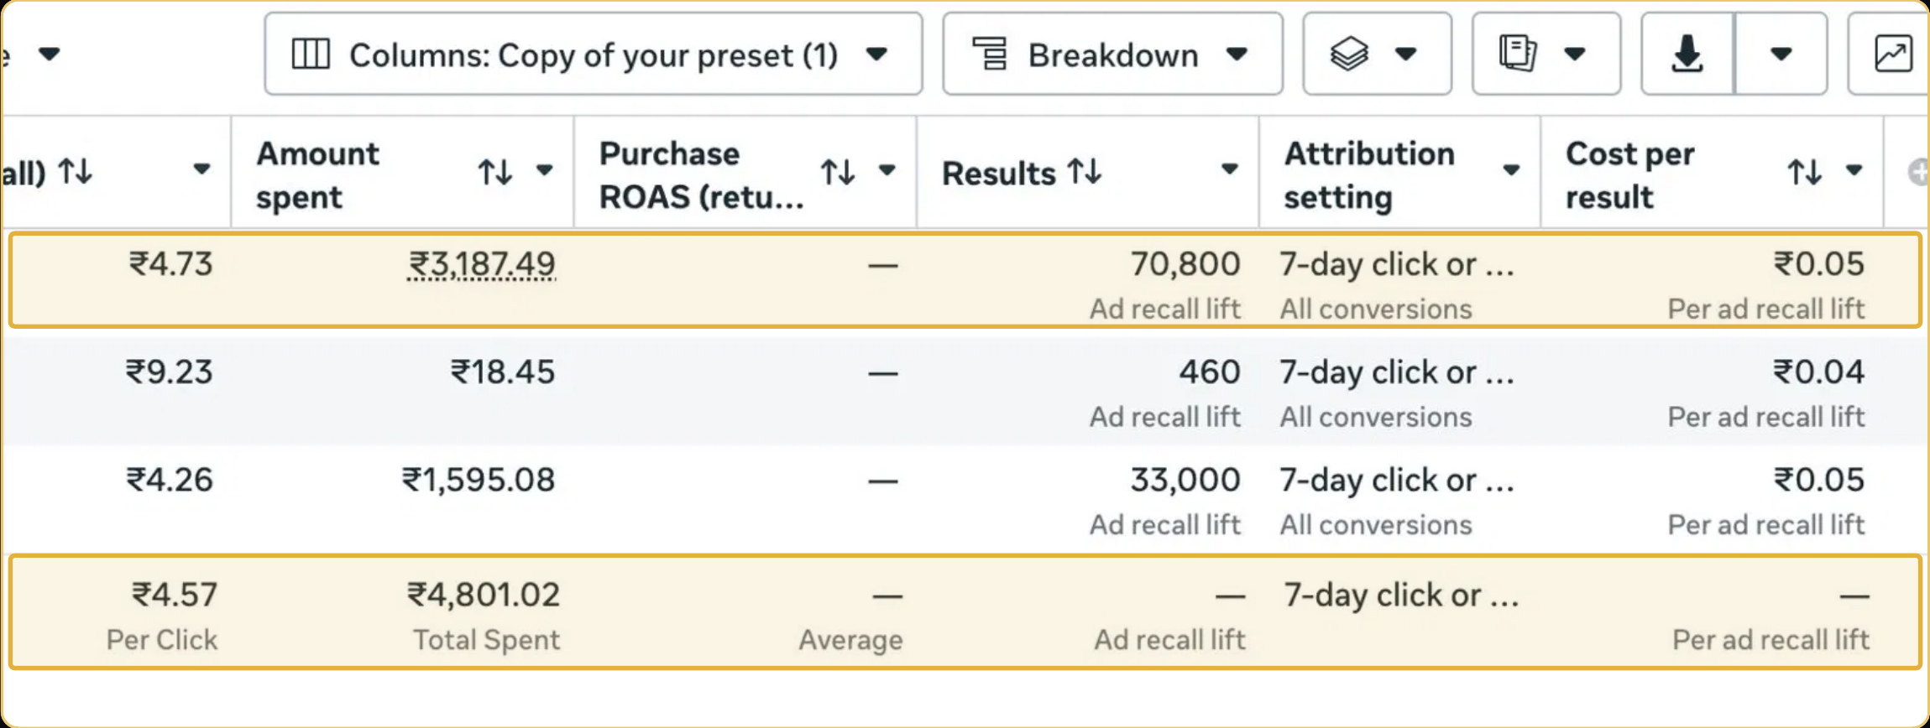
Figure 1. Ad-recall campaign reporting screenshot - original source image.

7. Results & Outcomes
The source reports 70,800 ad-recall lifts at ₹0.05 per lift, with total spend of approximately ₹4,801. One ad set generated 33,000 of those lifts at the same reported cost per lift. The figures are retained as reported. Because the cost figure is rounded in the source and does not reconcile exactly when multiplied by the total number of lifts, it should be labelled as a reported/rounded cost rather than used to calculate an exact implied spend. The source does not report purchases, leads or revenue from this test.
The main result was 70,800 ad-recall lifts for approximately ₹4,801. One ad set contributed 33,000 lifts at the same reported ₹0.05 cost per lift. The outcome supports a low-cost awareness story, not a purchase or revenue claim.

What stands out in the result
The case establishes an awareness result at a low stated unit cost. The reporting discrepancy between the stated cost per lift and total spend should be checked before the numbers are presented together as a precise calculation.

8. Key Learnings
- Awareness campaigns should be judged by the objective they were built for. Ad recall is not the same as a click or purchase.
- Cost per recall lift provides a clear efficiency measure for this particular test.
- Do not use the 70,800 recall lifts as a sales or revenue claim; those outcomes are not in the source.

BUSINESS VALUE AND CLOSE

9. Business Impact
The test generated 70,800 ad-recall lifts at a reported cost of ₹0.05 per lift from approximately ₹4,801 in spend. This gives the brand a measurable awareness result before the purchase stage. The largest named ad set contributed 33,000 recall lifts at the same reported cost per lift.
This is an awareness outcome, not evidence of sales. To measure the next business effect, the brand would need later evidence such as changes in branded search, store visits, conversions or the performance of audiences exposed to the campaign.

Business decisions this case can inform
Decision area | What the case suggests | What should be checked next
Awareness reporting | Use ad-recall lifts as the primary campaign result. | Brand search, store visits and later conversions.
Cost review | The stated ₹0.05 per lift needs reconciliation with total spend. | Confirm the report filters and calculation.
Next stage | Use the awareness result as an early-funnel measure. | Evidence of a lift in consideration or sales.

10. Conclusion
This case shows an awareness test built around ad recall. The campaign recorded 70,800 recall lifts at approximately ₹0.05 per lift from about ₹4,801 in spend. It supports a clear awareness result, but it does not provide evidence of purchases or revenue.

Publishing accuracy note
The source does not disclose the brand name, audience, reach, frequency, creative, dates, recall measurement method, subsequent sales or downstream campaign impact. The ₹0.05 cost is presented as reported and rounded; do not recompute or restate it as an exact audited rate. The campaign should not be described as generating 70,800 customers or buyers.

