CASE STUDY 10 | SEE ALL LIBRARY
Broader Campaign Set – 90 Days
1,183 purchases and 135,049 link clicks across a wider campaign mix

1. Case Study Overview
This 90-day campaign set combined purchase campaigns with wider exploratory activity and profile-visit objectives. The source presents it as a broad base of testing alongside stronger performers. It generated 1,183 purchases and 135,049 link clicks, with a reported average ROAS of 1.90x and average CPC of ₹2.55.
The source makes an important distinction: not every campaign needs to be a top performer. A healthy account can include exploratory campaigns and top-of-funnel activity alongside campaigns focused on purchases. This case documents a wider campaign set designed to keep discovery and testing active while still recording purchase outcomes over a 90-day window.

Performance snapshot from the original case record
Metric | Reported figure
Reporting window | 90 days
Purchases | 1,183
Average ROAS | 1.90x
Link clicks | 135,049
Average CPC | ₹2.55
Lowest reported profile-visit cost | ₹0.27

BUSINESS CONTEXT

2. The Challenge
If an account only keeps campaigns that already perform well, it may reduce the number of new ideas being tested. At the same time, exploratory activity needs to be measured honestly so that profile visits and clicks are not mistaken for purchases. The challenge was to operate a broader mix of campaign objectives and understand the different roles they played.
The account needed room for both conversion activity and exploration. Focusing only on campaigns already producing purchases can limit what the team learns about new audiences, while focusing only on traffic does not show whether the account is generating orders. The 90-day set included both types of activity.

What made this case difficult
The dashboard includes purchases, clicks and profile visits. They are not interchangeable. The 1.90x ROAS belongs to the purchase view, while profile visits indicate a different campaign objective. Keeping the result types separate prevents the account from appearing to have more sales than were actually reported.

Practical effect on the business
The account needed to avoid treating every result as a sale. Purchase campaigns, link clicks and profile visits represent different levels of intent. The reporting challenge is to keep them separate while understanding how they may connect over time.

3. Objective
The stated approach was to fund discovery intentionally. Purchase and profile-visit objectives were run side by side, giving the account a wider base of learning and top-of-funnel activity. The source does not provide a formal target for the 90-day period, nor does it state how many of the exploratory campaigns later became high-performing campaigns.
The account needed to produce website purchases while also maintaining top-of-funnel exploration. The reported measures cover purchases and ROAS as well as link clicks and profile visits. No specific target for each objective is stated.

Objective and available success measures
Objective area | Evidence available in the source
Purchase activity | 1,183 purchases
Purchase efficiency | 1.90x reported average ROAS
Traffic volume | 135,049 link clicks
Discovery activity | Some profile visits at ₹0.27 per visit

APPROACH AND DELIVERY

4. Strategy
The account combined campaigns designed for website purchases with exploratory activity at the top of the funnel. This is a broader account view: some campaigns were expected to generate purchases, while others supported profile visits and audience discovery. The source presents this as a 90-day mix rather than a single campaign built around one result type.
The practical value of this approach is that the account can keep learning while purchase campaigns are active. Profile visits are not purchases, so they need to be read separately. The reported 1.90x average ROAS belongs to the purchase reporting view, while the 135,049 link clicks and low-cost profile visits describe additional activity in the wider campaign set.

How the strategy addressed the business need
The account balanced immediate purchase activity with discovery. This allows the business to review what is converting now and what is building audiences for later work.

Why this structure fits the case
A mixed campaign set can keep existing purchase activity running while leaving room to test audiences and build engagement. The key is measurement discipline. The account should be reviewed by objective so a profile visit does not appear in the same performance column as a purchase.

5. Campaign Execution
A wider set of exploratory campaigns ran next to the headline performers. The account mixed website-purchase objectives with profile-visit objectives. This meant the campaign set was not judged only by immediate purchases; it also included activity designed to create visibility and audience engagement. Some profile-visit campaigns ran at a reported ₹0.27 per visit. The source describes these tests as a deliberate part of the account rather than accidental low-performing spend. It does not identify the campaign names, individual budgets, creative formats or subsequent conversion rates for the profile visitors.

Campaign or activity breakdown
Campaign / activity | Role in the account | Reported evidence
Website-purchase campaigns | Keep direct purchase activity in the campaign mix | 1,183 purchases; 1.90x average ROAS
Profile-visit campaigns | Support top-of-funnel activity | Some campaigns at ₹0.27 per visit
90-day broader set | Run exploratory activity alongside headline performers | 135,049 link clicks; ₹2.55 average CPC

The source reports the 90-day total and selected low-cost profile-visit activity. It does not identify the exact audience settings, creative variants or the later sales generated by profile visitors.
The 90-day set kept purchase campaigns active alongside profile-visit campaigns. This mix creates two distinct reporting lines: the purchase campaigns can be assessed through purchases and ROAS, while profile-visit campaigns can be assessed by visit volume and cost per visit. Some profile-visit campaigns reached ₹0.27 per visit. The source does not show whether those profile visitors later purchased.

NUMBERS AND REPORTING

6. Performance Analysis

Reading the main metrics
The 90-day result includes 1,183 purchases and a 1.90x average ROAS, alongside 135,049 link clicks at ₹2.55 average CPC. Some profile-visit campaigns ran at ₹0.27 per visit. A click, a profile visit and a purchase are different outcomes. The 1.90x ROAS should not be applied to profile visits unless a separate purchase report supports it.
The 1,183 purchases and 1.90x average ROAS describe purchase activity. The 135,049 link clicks provide traffic context, and the ₹0.27 profile-visit result belongs to a separate objective. A good performance review would keep those result types in their own rows and then check whether profile visitors later contributed to purchases. That follow-on result is not included here.

What the figures do and do not show
The source does not give revenue by product, gross margin or the later purchase rate of profile visitors. The purchase figures and profile-visit figures need to remain separate in any public summary.
Metric | Reported figure
Reporting window | 90 days
Purchases | 1,183
Average ROAS | 1.90x
Link clicks | 135,049
Average CPC | ₹2.55
Lowest reported profile-visit cost | ₹0.27

Original Dashboard Evidence
The following images are the original screenshots supplied in the source case-study document. They are included as visual supporting evidence and have not been altered.
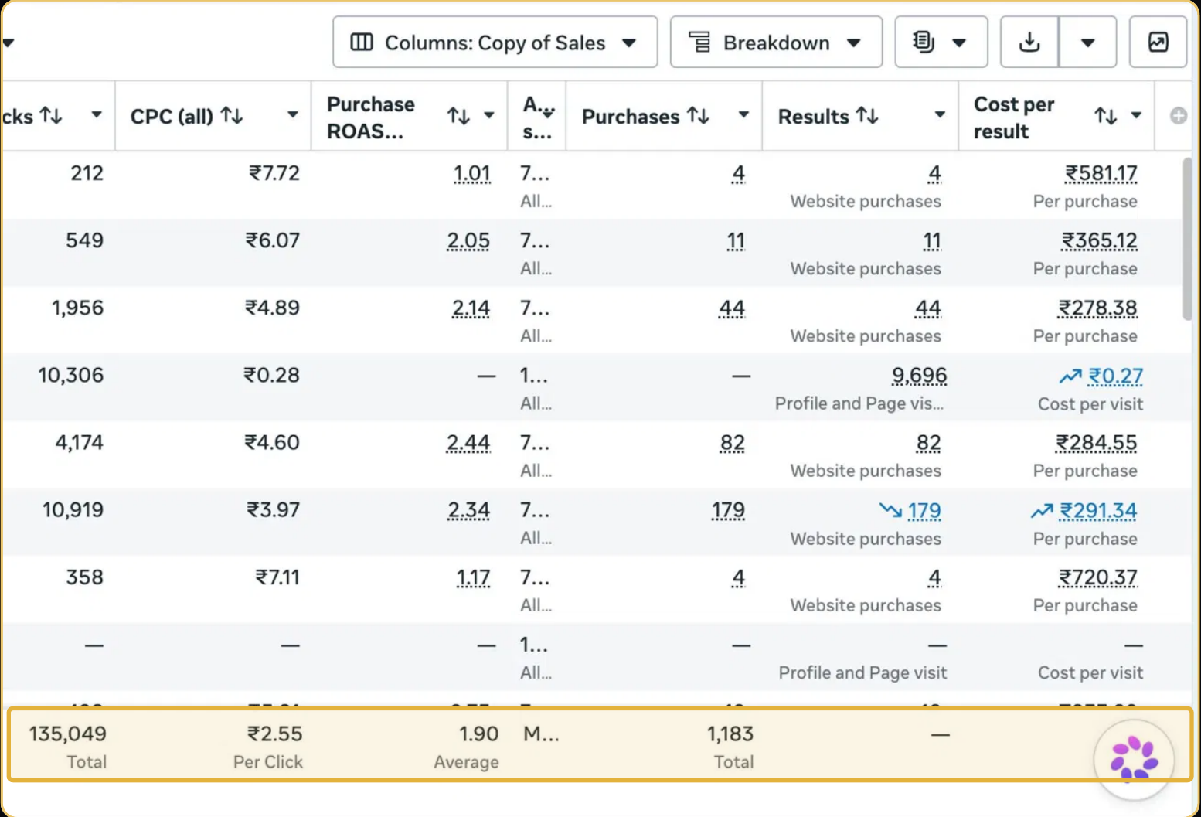
Figure 1. 90-day campaign reporting screenshot - original source image.

7. Results & Outcomes
Across the 90-day period, the account generated 1,183 purchases and 135,049 link clicks. The reported average ROAS was 1.90x, with average CPC of ₹2.55. Some profile-visit campaigns recorded a cost per visit of ₹0.27. These figures relate to different outcomes: purchases are sales events, link clicks are traffic actions and profile visits are engagement actions. The average ROAS should remain the account-level return measure; the ₹0.27 figure applies only to certain profile-visit campaigns.
The account generated 1,183 purchases during the 90-day period. It also recorded 135,049 link clicks, while some profile-visit campaigns delivered visits at ₹0.27 each. These outcomes show different layers of activity and should be reported in separate lines rather than merged into one result.

What stands out in the result
The account result includes both conversion activity and discovery activity. The purchase count and ROAS provide a commercial measure, while the click and profile-visit results show wider reach. The next step would be to connect those audiences to later purchase outcomes.

8. Key Learnings
- An account can include both purchase campaigns and discovery activity, but each objective needs its own performance measure.
- Read the reported 1.90x ROAS alongside the 1,183 purchases, and read profile visits separately from purchases.
- Exploratory campaigns can provide learning, but their value should be checked through later conversion performance where available.

BUSINESS VALUE AND CLOSE

9. Business Impact
The 90-day account combined purchase activity with a wider layer of discovery. It recorded 1,183 purchases, 135,049 link clicks and a 1.90x average ROAS, while some profile-visit campaigns ran at ₹0.27 per visit. This gives the business more than one kind of audience activity to review.
The commercial value of profile visits depends on whether those visitors later take a valuable action. That follow-on evidence is not included, so the strongest supported business impact is the reported purchase volume and the scale of traffic activity.

Business decisions this case can inform
Decision area | What the case suggests | What should be checked next
Purchase performance | Use 1.90x ROAS and 1,183 purchases for the purchase campaigns. | Margin and revenue by campaign.
Discovery activity | Track profile visits as a separate objective. | Share of visitors who later purchase.
Testing budget | Keep exploratory activity visible but measurable. | A defined follow-up window and conversion outcome.

10. Conclusion
This case shows a 90-day campaign set that combined website purchase activity with exploratory profile-visit campaigns. It recorded 1,183 purchases at 1.90x average ROAS and 135,049 link clicks. The purchase result and the profile-visit activity are different measures and should be presented separately.

Publishing accuracy note
The source does not provide total spend, total tracked revenue, the number of campaigns, names of the strongest campaigns, audience breakdowns or later conversion results from profile visitors. It does not confirm that exploratory campaigns became 6x campaigns; that is presented as the rationale for funding discovery, not as a measured result in this case.

