CASE STUDY 08 | SEE ALL LIBRARY
Lead Generation via Calls and WhatsApp
More than 10,000 calls and conversations from ₹27.2 lakh in spend

1. Case Study Overview
A service-led business needed phone calls and chat enquiries rather than website clicks. ScaleXpertz ran call and messaging campaigns separately, compared cost per result and shifted spend towards the more efficient channel. The source reports more than 10,000 calls and conversations from ₹27.2 L in ad spend.
For this business, a click to a website was not the main outcome. The team needed direct conversations that could be handled by the sales operation. Calls and messaging were therefore treated as distinct campaign objectives, with performance compared through their cost per result rather than by looking only at traffic volume.

Performance snapshot from the original case record
Metric | Reported figure
Total ad spend | ₹27.2 L
Calls and conversations | 10K+
Lowest reported cost per call | ₹6.62
Average CPC | ₹1.18
Best call campaign | 4,116 calls at ₹6.62
Messaging campaign | 3,627 conversations at ₹19.72

BUSINESS CONTEXT

2. The Challenge
Phone calls and messaging conversations are different actions. Their costs and the way the sales team follows them up can also differ. Combining them into one broad result number would make it harder to understand which channel was delivering each type of enquiry. The account needed separate campaigns and clear cost-per-result comparisons.
A service-led business needs enquiries that its team can answer and follow up. Website visits do not automatically create a sales conversation. The account therefore had to focus on calls and messages and make it possible to compare the cost of each type of contact.

What made this case difficult
The source shows that the call campaigns did not have the same cost per result. One generated calls at ₹6.62 each and another at ₹12.15. The messaging campaign generated conversations at ₹19.72 each. Comparing them requires keeping the result type in view.

Practical effect on the business
If the account had optimised only for clicks, it might have generated website traffic without enough direct enquiries. Separating calls and messages gave the business a way to see which action was being generated at what cost, while recognising that a cheaper contact is not automatically a better lead.

3. Objective
The stated need was to generate calls and chat enquiries. The source does not identify the service category, lead qualification process, call duration, appointment rate or conversion into paying customers. The documented objective is therefore enquiry generation, not confirmed sales or revenue.
The objective was to generate phone calls and messaging conversations at a measurable cost. The correct comparison is cost per call against cost per messaging conversation, rather than against website clicks. The source does not state a target for qualified leads, appointments or closed sales.

Objective and available success measures
Objective area | Evidence available in the source
Phone enquiries | 4,116 calls at ₹6.62 and 2,494 at ₹12.15
Message enquiries | 3,627 conversations at ₹19.72
Combined contact volume | More than 10,000 calls and conversations
Spend context | ₹27.2 L reported total spend

APPROACH AND DELIVERY

4. Strategy
The strategy focused on the action the business needed: phone calls and message conversations. Website traffic alone would not have answered the brief described in the source. Call campaigns and messaging campaigns were therefore run separately so their cost per result could be compared on a like-for-like basis.
This separation is important because a phone call and a messaging conversation are different lead actions. The strongest call campaign was assessed by its cost per call, while the WhatsApp/messaging campaign was assessed by its cost per conversation. Spend was shifted towards the lower-cost channel, according to the account description. The source does not report how many of these contacts became qualified leads or paying customers.

How the strategy addressed the business need
Separate call and messaging campaigns helped the business compare the cost of the two contact types without treating them as one result.

Why this structure fits the case
This case is built around lead action, not just media delivery. A phone call gives the sales team a direct conversation, while a message creates a written enquiry that may be handled differently. Separating them makes the cost comparison clearer. The next decision should depend on qualified lead and sale outcomes as well as the initial cost of the contact.

5. Campaign Execution
ScaleXpertz ran call campaigns and messaging campaigns separately and compared their cost per result. The best call campaign generated 4,116 calls at ₹6.62 each. Another call campaign delivered 2,494 calls at ₹12.15 each. A messaging campaign generated 3,627 conversations at ₹19.72 each. This separation allowed spend to be shifted towards the lowest-cost channel while keeping call and messaging outcomes distinct. The source does not provide the exact audiences, creative, call scripts, WhatsApp automation, lead qualification rules or sales follow-up process, so those are not described as part of the execution.

Campaign or activity breakdown
Campaign / activity | Role in the account | Reported evidence
Call campaigns | Generate direct phone enquiries | 4,116 calls at ₹6.62; another 2,494 at ₹12.15
Messaging campaign | Generate chat conversations | 3,627 conversations at ₹19.72
Separate reporting and budget shifts | Compare cost per result by action type | ₹27.2 L spend; 10K+ calls and conversations

Calls and messaging conversations are shown as separate result types. The source does not report call duration, answered-call rate, lead qualification, appointment rate or final sales.
Call campaigns and messaging campaigns were run separately. That separation gave the business a direct comparison between the cost of a phone call and the cost of a conversation. The best call campaign produced 4,116 calls at ₹6.62; another produced 2,494 at ₹12.15; and messaging generated 3,627 conversations at ₹19.72. The source says spend was shifted toward the lowest-cost channel, but it does not say whether lead quality was equal across the channels.

NUMBERS AND REPORTING

6. Performance Analysis

Reading the main metrics
The account spent ₹27.2 lakh and generated more than 10,000 calls and conversations. The named outcomes were 4,116 calls at ₹6.62 each, 2,494 calls at ₹12.15 each and 3,627 messaging conversations at ₹19.72 each. The ₹1.18 average CPC is a click metric, not the cost per call or conversation. Contact actions do not establish how many leads became customers.
The campaign results add up to 10,237 named actions: 6,610 calls across the two call campaigns and 3,627 messaging conversations. This is consistent with the source's summary of more than 10,000 calls and conversations. The ₹6.62 figure is the lowest reported cost per call, while ₹19.72 is the cost per messaging conversation. They should not be compared as if each contact has the same value to the sales team.

What the figures do and do not show
No qualified-lead rate, answer rate, appointment rate, conversion to customer or revenue from calls and messages is supplied. The reported figures measure contact volume and cost, not final sales.
Metric | Reported figure
Total ad spend | ₹27.2 L
Calls and conversations | 10K+
Lowest reported cost per call | ₹6.62
Average CPC | ₹1.18
Best call campaign | 4,116 calls at ₹6.62
Messaging campaign | 3,627 conversations at ₹19.72

Original Dashboard Evidence
The following images are the original screenshots supplied in the source case-study document. They are included as visual supporting evidence and have not been altered.
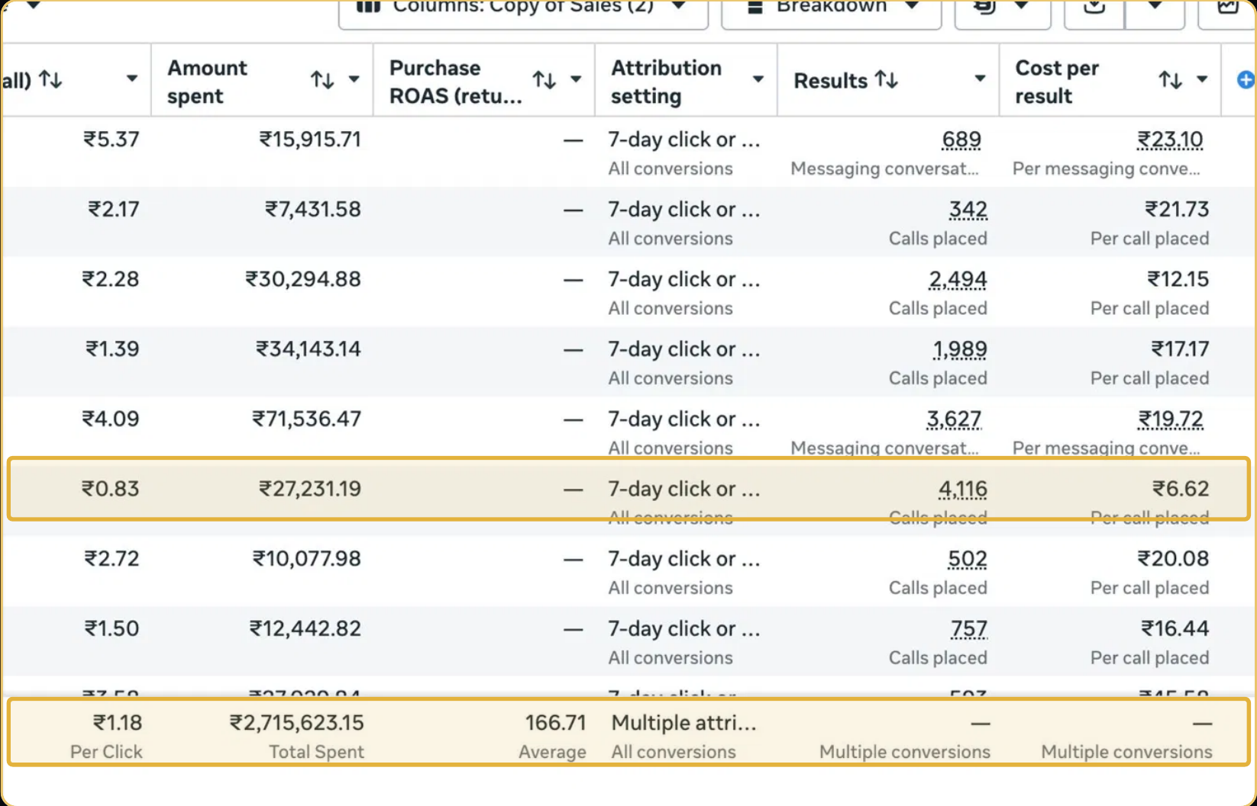
Figure 1. Calls and messaging campaign results screenshot - original source image.

7. Results & Outcomes
The account spent ₹27.2 L and generated more than 10,000 calls and conversations. The three named campaign results add up to 10,237 actions: 4,116 calls at ₹6.62, 2,494 calls at ₹12.15 and 3,627 messaging conversations at ₹19.72. The source reports an average CPC of ₹1.18. Cost per call, cost per messaging conversation and cost per click measure different actions, so they should not be compared as though they represent the same outcome. The 10K+ total should also not be described as 10,000 qualified or paying customers.
The named call and messaging campaigns total 10,237 contact actions: 4,116 calls, 2,494 calls and 3,627 conversations. The source rounds this to more than 10,000 calls and conversations. The results show volume and cost by action type, but not the later sales outcome.

What stands out in the result
The result is a high number of direct contact actions. The cost of a call and the cost of a message are both visible, which gives the business a way to compare the channels. The case remains a lead-volume story until lead quality and sales are measured.

8. Key Learnings
- Choose the campaign objective based on the real action the sales team needs: calls and messages are not interchangeable with website clicks.
- Compare cost per call separately from cost per messaging conversation.
- Measure lead quality and sales outcomes as a next step. The source reports contact actions, but not qualified leads or closed sales.

BUSINESS VALUE AND CLOSE

9. Business Impact
The campaigns generated more than 10,000 call and messaging actions from a total reported spend of ₹27.2 lakh. The lowest reported call cost was ₹6.62, while the messaging campaign generated conversations at ₹19.72 each. For a service-led business, this can create a larger flow of direct enquiries for the sales team to handle.
The business impact beyond enquiry volume is not supplied. The source does not show how many calls were answered, how many conversations were qualified or how many became paying customers. Lead quality and closed revenue would be the next measures needed to assess commercial value.

Business decisions this case can inform
Decision area | What the case suggests | What should be checked next
Channel choice | Compare call and messaging costs separately. | Lead quality and close rate by contact type.
Sales follow-up | More than 10,000 contact actions create follow-up work. | Answer rate, response time and qualified leads.
Budget allocation | Lowest call cost was ₹6.62. | Revenue per qualified call or conversation.

10. Conclusion
This case shows a lead-generation account focused on phone calls and messaging conversations rather than website visits. It recorded more than 10,000 contact actions from ₹27.2 lakh in spend, with a lowest reported call cost of ₹6.62. The next measure needed to assess commercial impact would be lead qualification and conversion to customers.

Publishing accuracy note
The source does not disclose the business category, campaign dates, lead quality, unique caller count, call duration, qualified leads, appointments, customer sales or revenue. It does not confirm that every call or message was unique. The 10K+ figure refers to campaign results and should not be presented as 10,000 customers.

