CASE STUDY 06 | HOMEPAGE FEATURED - RANK 3
Automotive Accessories
9,319 purchases with 11.27x average ROAS across 38 campaigns

1. Case Study Overview
An automotive-accessories brand selling lights, tools and bike parts operated in a category where buyers compare prices closely. ScaleXpertz matched products with audiences and formats across 38 campaigns. The account recorded 9,319 purchases and an average 11.27x ROAS. The strongest reported campaign reached 22.30x.
The brand sold a mix of automotive accessories, including lights, tools and bike parts. The source notes that customers in this category compare prices relentlessly. Different products therefore needed different campaign treatment. The case focused on matching each product with an audience and format that could produce a measurable response.

Performance snapshot from the original case record
Metric | Reported figure
Average ROAS | 11.27x across 38 campaigns
Purchases | 9,319
Best campaign ROAS | 22.30x
Average CPC | ₹0.92
Influencer fog-light campaign | 14.71x / 260 purchases
Broad scaling campaign | 1,817 purchases / 13.02x

Homepage position: Featured case #3 in the five-case homepage selection. The complete case remains part of the full case-study library.

BUSINESS CONTEXT

2. The Challenge
A broad campaign structure can hide differences between product types. A car-wash spray gun, fog lights and other accessories do not necessarily attract the same shoppers or respond to the same creative. The account needed enough separation to identify product-specific winners while also supporting campaigns capable of delivering purchase volume at scale.
Automotive accessory buyers compare prices and products carefully. The account had different items such as lights, tools and bike parts, so the same creative and audience were unlikely to be equally relevant to every product. The challenge was to find product-and-format combinations that could deliver purchases, not only cheap visits.

What made this case difficult
The account had to support different products and different response types. The 9,319 purchases are purchase outcomes, while the second reporting view includes 19,209 total results and low-cost profile visits. These numbers describe different dashboard measures and should not be combined into a purchase total.

Practical effect on the business
A low cost per click is not enough in a competitive category. The business needed campaigns that could lead to purchases, while still making use of lower-cost visits where they could support retargeting. The separate reporting views help show both types of activity without treating them as equal outcomes.

3. Objective
The stated need was to match each product to its own audience and format, while producing purchases at efficient costs. The source does not include a formal sales target, total ad spend or margin target. The reported outcome is therefore based on campaign ROAS, purchases, CPC and the named campaign results.
The objective was to generate purchases efficiently across products with different audiences and creative needs. A secondary role for low-cost profile visits was to build audiences for retargeting. The source does not state a formal purchase target or revenue target.

Objective and available success measures
Objective area | Evidence available in the source
Purchase scale | 9,319 purchases
Account return | 11.27x average ROAS across 38 campaigns
Product-level winners | 22.30x and 14.71x named campaign results
Audience activity | Separate view: 19,209 total results

APPROACH AND DELIVERY

4. Strategy
The strategy was product-specific rather than one broad message for every accessory. Lights, tools and bike parts were matched with different audiences and creative formats. The reported examples show three distinct approaches: retargeting for the car-wash spray gun, influencer-led creative for fog lights and a broad scaling campaign for purchase volume.
The account also produced low-cost profile visits alongside purchases. Those results should not be treated as the same outcome. The source describes profile visits as a source of audiences for retargeting, while purchases show completed buying actions. Keeping the two views separate helps explain how traffic activity and conversion activity can support different parts of the customer journey.

How the strategy addressed the business need
The account's product-specific approach is reflected in the different examples: retargeting for the spray gun, influencer content for fog lights and broad scaling for wider purchase volume.

Why this structure fits the case
The source shows the value of matching an approach to the product. Retargeting was used for the spray gun, creator-led content for fog lights, and a broad campaign for scale. These are different ways of reaching and converting people. The account also kept low-cost profile visits in view as audience activity, but did not count those visits as purchases.

5. Campaign Execution
ScaleXpertz matched products with their own audiences and formats. The car-wash spray gun retargeting set reached 22.30x ROAS. Influencer-led fog-light creative reached 14.71x ROAS and generated 260 purchases. A broad scaling campaign generated 1,817 purchases at ₹46.20 each, with 13.02x ROAS. These examples show that different campaign roles contributed in different ways: retargeting delivered a very high reported return, creator-led content produced a strong fog-light result, and broad scaling supported substantial order volume. The source does not provide the exact audience definitions, creator identity, creative scripts, campaign budgets or product margins.

Campaign or activity breakdown
Campaign / activity | Role in the account | Reported evidence
Car-wash spray gun retargeting | Reconnect with interested shoppers for this product | 22.30x ROAS
Influencer-led fog-light creative | Use creator-led product content | 14.71x ROAS; 260 purchases
Broad scaling campaign | Support wider purchase volume | 1,817 purchases; ₹46.20 per purchase; 13.02x ROAS
38-campaign account | Run product-specific audience and format combinations | 11.27x average ROAS; 9,319 purchases

The results table keeps the purchase outcomes separate from the wider results view. The source does not disclose the audience sizes, product margins, campaign budgets or exact attribution settings.
The named examples show how the account varied its approach by product. The car-wash spray gun used a retargeting set; fog lights used influencer-led creative; and the broad scaling campaign generated a larger number of purchases. The additional reporting view included profile visits as well as other results. This is important when explaining the case: the account generated purchase volume and audience activity, but the two are measured separately.

NUMBERS AND REPORTING

6. Performance Analysis

Reading the main metrics
The account average was 11.27x ROAS across 38 campaigns, with 9,319 purchases and ₹0.92 average CPC. The best named campaign reached 22.30x. The fog-light influencer creative reported 14.71x with 260 purchases, while broad scaling reported 13.02x with 1,817 purchases at ₹46.20 per purchase. A separate view showed 19,209 total results at ₹0.74 per click, including profile visits. The two click-cost figures belong to separate report views.
The 22.30x car-wash spray-gun retargeting campaign was close to twice the account average of 11.27x. The fog-light influencer campaign at 14.71x and the broad scaling campaign at 13.02x also exceeded the account average. The broad campaign's 1,817 purchases give a sense of its volume contribution. These figures show both high-return examples and substantial purchase volume, rather than relying on one measure alone.

What the figures do and do not show
Purchase counts, profile visits and total results are different measures. The source does not provide product margin, refunds, repeat purchases or full revenue attribution. The best campaign result should not be reported as the average for the account.
Metric | Reported figure
Average ROAS | 11.27x across 38 campaigns
Purchases | 9,319
Best campaign ROAS | 22.30x
Average CPC | ₹0.92
Influencer fog-light campaign | 14.71x / 260 purchases
Broad scaling campaign | 1,817 purchases / 13.02x

Original Dashboard Evidence
The following images are the original screenshots supplied in the source case-study document. They are included as visual supporting evidence and have not been altered.
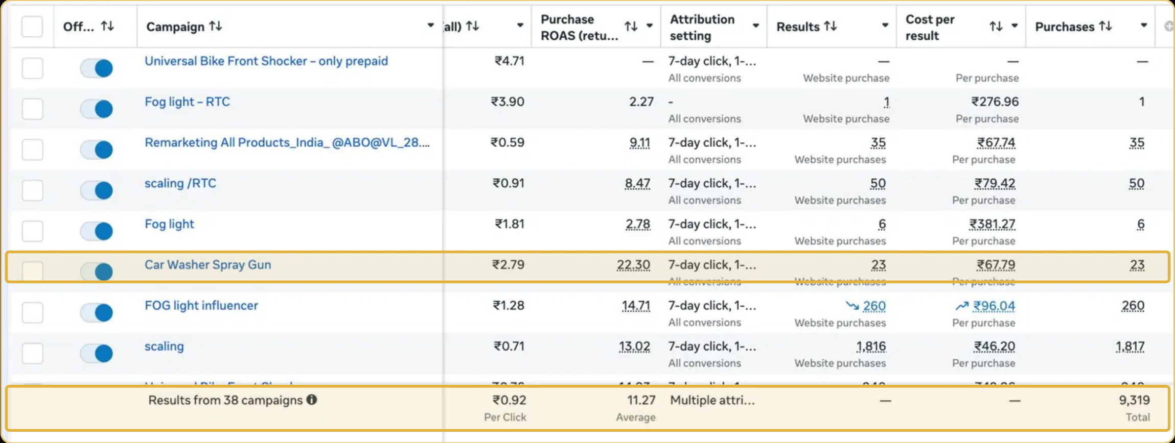
Figure 1. Meta Ads campaign and results reporting screenshot - original source image.
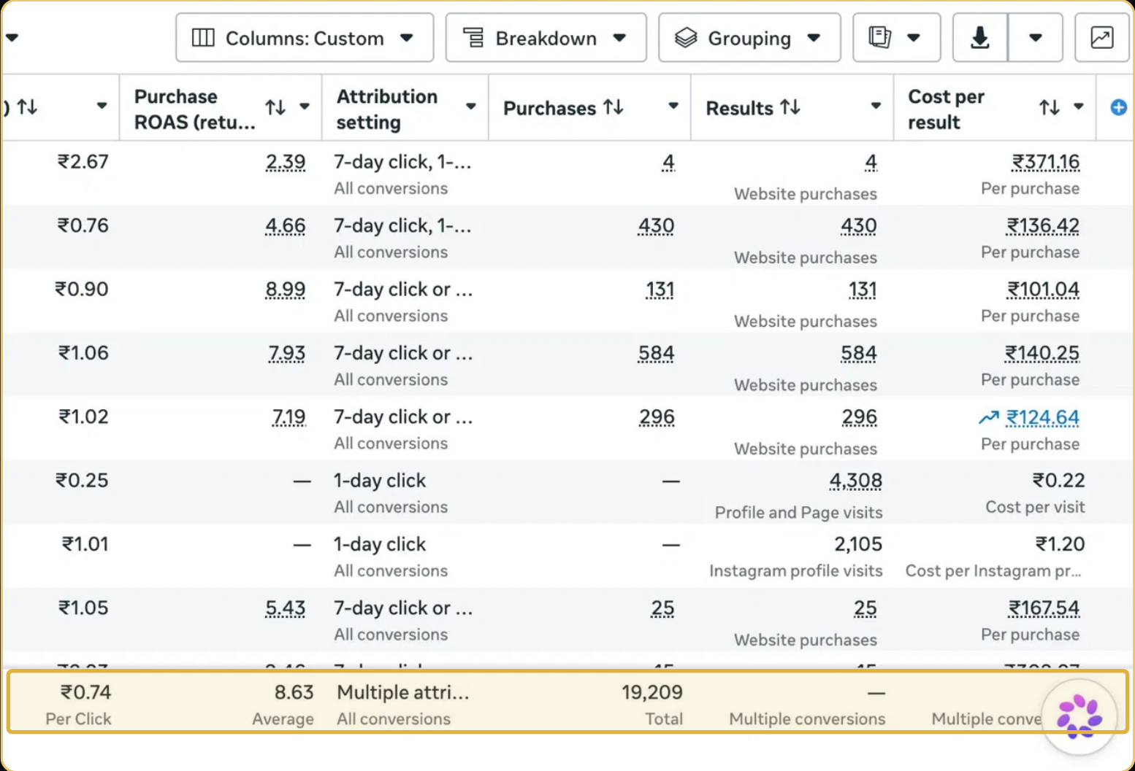
Figure 2. Meta Ads campaign and results reporting screenshot - original source image.

7. Results & Outcomes
Across 38 campaigns, the reported average ROAS was 11.27x, with 9,319 purchases and average CPC of ₹0.92. The best named campaign reached 22.30x. The influencer-led fog-light campaign returned 14.71x and generated 260 purchases. The broad scaling campaign delivered 1,817 purchases at ₹46.20 each and 13.02x ROAS. A second reporting view shows 19,209 total results at ₹0.74 per click, including thousands of low-cost profile visits. That second view covers multiple result types and should not be confused with the 9,319 purchase figure.
The three named examples show the range of outcomes inside the account: 22.30x for car-wash spray-gun retargeting, 14.71x for influencer-led fog-light creative and 13.02x for broad scaling. The account-wide result of 9,319 purchases at 11.27x average ROAS gives the wider context.

What stands out in the result
The result combines a strong average return with several clear campaign examples. Retargeting, influencer content and broad scaling all appear in the named winners. It shows that the account was not relying on just one format, while the purchase and profile-visit views remain separate.

8. Key Learnings
- Match the campaign format to the product and audience instead of using one message for every automotive accessory.
- Keep purchase results separate from profile visits and other low-cost actions. They support different stages and should not be reported as the same conversion.
- A strong individual campaign and the account average tell different stories. The 22.30x result was the best named campaign; 11.27x was the reported average across 38 campaigns.

BUSINESS VALUE AND CLOSE

9. Business Impact
The account generated 9,319 purchases across 38 campaigns and reported an average ROAS of 11.27x. Product-level examples show that different formats could work for different items, while the wider results view also included profile visits that could support future retargeting.
This gives the business both purchase scale and a larger audience-building activity. The case does not show profit by product, repeat buying or the eventual sales from the profile-visit audience. Those outcomes should not be assumed from low-cost clicks alone.

Business decisions this case can inform
Decision area | What the case suggests | What should be checked next
Product and format fit | Different products had different leading campaign approaches. | Margin and purchase quality by product.
Audience building | Profile visits can support later retargeting. | Evidence that visitors later purchased.
Scale decisions | Use the 11.27x account average, not only the 22.30x peak. | Spend and attribution by campaign.

10. Conclusion
This case shows a product-specific approach to automotive accessories, with a reported 11.27x average ROAS and 9,319 purchases across 38 campaigns. The strongest named campaign reached 22.30x, while influencer-led and broad-scaling examples also delivered strong results. Purchase results and profile-visit activity should be kept separate.

Publishing accuracy note
The source does not state total campaign spend, campaign dates, product revenue, margin, inventory levels or the exact attribution settings. The 19,209 multiple-result figure is a separate dashboard view and includes profile visits; it is not an alternative purchase count. The ₹0.92 average CPC and ₹0.74 secondary-view CPC should remain tied to their respective reporting views.

