CASE STUDY 05 | SEE ALL LIBRARY
Mobile Accessories
50 campaigns helped identify a hero product at 7.06x ROAS

1. Case Study Overview
A mobile-accessories catalogue with many SKUs needed a reliable way to identify which products deserved more budget. ScaleXpertz separated the catalogue into 50 campaigns and used the performance results to rank products. The premium leather case emerged as the hero product at 7.06x ROAS. The account recorded 1,469 purchases at an average ROAS of 3.52x.
A large accessories catalogue can contain products with very different levels of demand and different economics. Giving every SKU the same budget can make it harder to identify the products that can carry the account. The source describes a business with many SKUs that needed to learn quickly which products deserved budget.

Performance snapshot from the original case record
Metric | Reported figure
Average ROAS | 3.52x
Purchases | 1,469
Average CPC | ₹2.45
Top campaign ROAS | 7.06x
Top CPA-focused campaign | 4.62x / 54 purchases
Anti-yellowing line | 3.85x / 94 purchases

BUSINESS CONTEXT

2. The Challenge
The key challenge was product selection. Rather than assuming that every product would perform in the same way, the campaign structure needed to generate enough information to compare products and move attention towards stronger performers. The account also needed to distinguish the overall result from the results of individual products and campaign groups.
A catalogue with many SKUs creates a budget-allocation problem. Giving every product equal attention can leave money behind products that are not producing enough orders, while strong products may not receive enough support. The business needed a clear way to compare items using the same account data.

What made this case difficult
The number of campaigns is evidence of the breadth of testing, but the useful result is the product difference. The premium leather case reached 7.06x ROAS, while the anti-yellowing line reached 3.85x. These examples show why SKU-level reporting matters.

Practical effect on the business
Without product-level comparisons, the business may continue spending on low-performing SKUs or miss a product that can carry more of the account. The difference between the 7.06x leather-case result and the 3.52x account average makes the value of that comparison clear.

3. Objective
The stated need was to learn quickly which products deserved the budget. The source does not disclose a target number of orders, a target ROAS or a required cost per purchase. The outcome is therefore reported through the average account ROAS, purchase volume, CPC and the performance of the strongest product lines.
The objective was to find the products that deserved more investment within a large mobile-accessories catalogue. Purchases and ROAS provide the main evidence, while click cost adds context about how cheaply shoppers were reached. The source does not state a target for each SKU.

Objective and available success measures
Objective area | Evidence available in the source
Catalogue learning | 50 campaigns used to compare products
Purchase volume | 1,469 purchases
Account return | 3.52x average ROAS
Product winner | Premium leather case at 7.06x ROAS

APPROACH AND DELIVERY

4. Strategy
The strategy was to let product-level performance decide where the budget should go. Instead of treating every mobile accessory SKU equally, the catalogue was divided across 50 campaigns. This gave the team many product and campaign combinations to compare and helped reveal which items were producing stronger returns.
The premium leather case became the clearest hero product, while the cost-per-purchase campaign and anti-yellowing line provided additional examples of products that could contribute. The account average is important too: the goal was not only to find one high-return item, but to understand how the wider catalogue performed while the strongest products were identified.

How the strategy addressed the business need
This approach makes the catalogue itself a source of learning. The account could identify a leading item, compare it with other lines and use evidence from the campaign results when deciding where more budget may be useful.

Why this structure fits the case
Product-level campaign comparison helps the team make a more informed decision about where to put the next unit of budget. The hero leather case's 7.06x result makes it a strong candidate for further review, but the 3.52x account average keeps the decision grounded in the wider catalogue. The case does not provide the margin or stock data needed to make a final profit-based SKU decision.

5. Campaign Execution
The catalogue was split into 50 campaigns so the numbers could show which products were performing. The premium leather case emerged as the hero at 7.06x ROAS. A top-performer cost-per-purchase campaign followed at 4.62x with 54 purchases, while the anti-yellowing line reached 3.85x with 94 purchases. This structure created a way to compare products instead of spreading budget evenly across every SKU. The source does not identify the exact audience structure, creative formats, price points, daily budgets or the duration of the campaigns, so those details are not added.

Campaign or activity breakdown
Campaign / activity | Role in the account | Reported evidence
50-campaign product test | Compare a large SKU range using campaign results | 1,469 purchases; 3.52x average ROAS
Premium leather case | Identify the strongest product campaign | 7.06x ROAS
Cost-per-purchase campaign | Track a named purchase-focused performer | 4.62x ROAS; 54 purchases
Anti-yellowing line | Measure another product line separately | 3.85x ROAS; 94 purchases

The source provides selected product-level results, not a full report for all 50 campaigns. The table therefore highlights the named examples without implying that they represent every SKU.
The 50-campaign structure gave the team a wide comparison set. The premium leather case emerged as the strongest named product campaign. A cost-per-purchase performer and the anti-yellowing line also showed that more than one SKU could contribute. The account-level total then gives the larger view: these selected winners sat inside a campaign set that generated 1,469 purchases at 3.52x average ROAS.

NUMBERS AND REPORTING

6. Performance Analysis

Reading the main metrics
The 3.52x average ROAS is the overall account figure. The premium leather case reached 7.06x, which is a specific campaign result and not the average for the whole catalogue. Other named examples were 4.62x with 54 purchases and 3.85x with 94 purchases. The ₹2.45 figure is average cost per click, not cost per purchase.
The premium leather case's 7.06x ROAS is approximately twice the 3.52x account average. This makes it a clear hero-product example, but it does not mean the whole catalogue returned 7.06x. The 4.62x campaign with 54 purchases and the anti-yellowing line at 3.85x with 94 purchases show additional product-level results. The ₹2.45 average CPC describes traffic cost, not purchase cost.

What the figures do and do not show
The source does not provide product-level margins, inventory availability or return rates. The 7.06x hero result is a campaign metric and does not by itself prove that the product delivered the highest profit.
Metric | Reported figure
Average ROAS | 3.52x
Purchases | 1,469
Average CPC | ₹2.45
Top campaign ROAS | 7.06x
Top CPA-focused campaign | 4.62x / 54 purchases
Anti-yellowing line | 3.85x / 94 purchases

Original Dashboard Evidence
The following images are the original screenshots supplied in the source case-study document. They are included as visual supporting evidence and have not been altered.
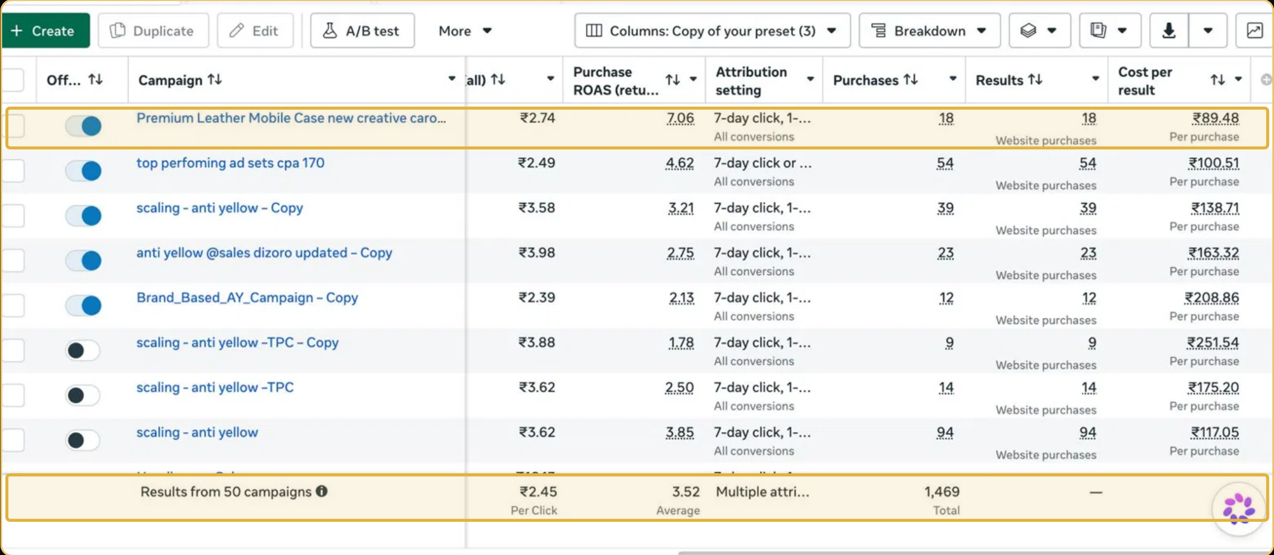
Figure 1. Meta Ads campaign performance screenshot - original source image.

7. Results & Outcomes
Across the account, the reported average ROAS was 3.52x and the campaign set generated 1,469 purchases. Average cost per click was ₹2.45. The premium leather case was the strongest named product, reaching 7.06x ROAS. The top-performer cost-per-purchase campaign recorded 4.62x ROAS with 54 purchases. The anti-yellowing product line recorded 3.85x ROAS with 94 purchases. CPC and cost per purchase are different metrics: ₹2.45 is the average cost per click, not the cost to acquire an order.
The premium leather case was the strongest named product campaign at 7.06x ROAS. A cost-per-purchase campaign recorded 4.62x with 54 purchases, and the anti-yellowing line delivered 3.85x with 94 purchases. Across the account, the result was 1,469 purchases at 3.52x average ROAS.

What stands out in the result
The key outcome is not simply that one product reached a high ROAS. The account also recorded 1,469 purchases at a 3.52x average, while two other product examples returned 4.62x and 3.85x. This shows a range of performance inside a large catalogue.

8. Key Learnings
- A large catalogue does not need every SKU to receive equal budget. Product-level campaign results can help identify the items worth prioritising.
- Keep account averages in view. A 7.06x hero campaign is notable, but the overall account average was 3.52x.
- Track product-level outcomes so that a winner can be identified with evidence rather than preference.

BUSINESS VALUE AND CLOSE

9. Business Impact
The business gained a clearer view of which products were capable of carrying more of the account's performance. The premium leather case stood out at 7.06x ROAS, while the full account averaged 3.52x and recorded 1,469 purchases. This gives the business a product-level basis for prioritising budget rather than spreading it evenly.
The result is useful for catalogue planning, but it does not show profit by SKU or stock availability. A product with a high reported ROAS still needs to be assessed against margin, returns and fulfilment capacity before it receives more budget.

Business decisions this case can inform
Decision area | What the case suggests | What should be checked next
SKU allocation | Prioritise products supported by campaign results. | Gross margin and stock availability by SKU.
Hero-product planning | The leather case was the strongest named campaign. | Repeatability over time and inventory depth.
Account view | Use 3.52x as the overall reported average. | Profit after product and fulfilment costs.

10. Conclusion
This case shows how product-level testing can identify the items that deserve more attention in a large accessories catalogue. The account recorded 1,469 purchases and 3.52x average ROAS, while the premium leather case reached 7.06x. The strongest result belongs to that campaign; the account average describes the wider catalogue.

Publishing accuracy note
The source does not provide the total spend, revenue, campaign period, gross margin, return rate, inventory availability or product prices. It does not show whether the 50 campaigns ran simultaneously throughout the full period. No claim about profit or the long-term sales potential of the hero product should be made from ROAS alone.

