CASE STUDY 04 | HOMEPAGE FEATURED - RANK 1
Bangles and Fashion Jewellery
₹2.82 Cr in store revenue over 90 days, up 189%

1. Case Study Overview
A fashion-jewellery D2C brand in a price-sensitive, impulse-driven category needed to grow order volume without losing control of performance. ScaleXpertz ran 38 campaigns in structured batches, testing designs, bundles and catalogue formats while monitoring order, delivery and ROAS data. The source reports ₹2.82 Cr in store revenue over 90 days, 38,673 orders and 189% revenue growth.
Fashion jewellery is a category where customers may compare prices quickly and make purchase decisions based on design, bundle value and product presentation. The source describes the brand as operating in a price-sensitive, impulse-driven market. The business needed order volume, but growth also had to be managed carefully so that weak combinations did not continue consuming budget.

Performance snapshot from the original case record
Metric | Reported figure
Store revenue | ₹2.82 Cr / 90 days
Orders | 38,673
Revenue growth | +189% period over period
Live campaigns | 38
Strong campaign ROAS | Up to 5.05x
Highest reported CTR | 7.04%

Homepage position: Featured case #1 in the five-case homepage selection. The complete case remains part of the full case-study library.

BUSINESS CONTEXT

2. The Challenge
The account needed enough live testing to identify designs and formats that could bring in purchases, while also responding quickly when an ad set stopped performing. Creative fatigue was a stated risk in this category. The operating challenge was therefore ongoing: keep testing new designs, bundles and catalogue formats, measure the results frequently and cut weak ad sets before they absorbed too much spend.
The category is described as price-sensitive and impulse-driven. In that setting, a campaign can lose momentum if the same design or creative is shown for too long. The account therefore needed a repeatable way to test new combinations and remove weak ad sets before they absorbed too much budget.

What made this case difficult
The task was to keep testing while controlling waste. The source specifically mentions watching daily order, delivery and ROAS data and cutting weak ad sets quickly. It does not state the exact cut-off thresholds or the names of the products and bundles tested.

Practical effect on the business
The account needed to make decisions frequently because the source identifies creative fatigue as a risk. Waiting too long to react could leave budget in designs or formats that had stopped working. Reviewing delivery as well as order and ROAS data also kept the campaign decision connected to what happened after an order was generated.

3. Objective
The source frames the need as growing volume without burning margin. It does not provide a gross-margin figure or a precise profitability threshold. The reported commercial outcome is therefore store revenue, order volume and period-over-period growth; campaign efficiency metrics are presented separately where the source gives them.
The objective was to increase store revenue and order volume without allowing weak campaign combinations to consume the budget. The source reports the store-level growth and the account's testing activity, but does not include a written target for ROAS, cost per order or margin.

Objective and available success measures
Objective area | Evidence available in the source
Store growth | ₹2.82 Cr revenue over 90 days
Order volume | 38,673 orders
Campaign coverage | 38 live campaigns
Ad efficiency evidence | Separate reporting view: 3.62x; strong campaigns up to 5.05x

APPROACH AND DELIVERY

4. Strategy
The strategy was built around continuous product and format testing. Thirty-eight campaigns were run in structured batches so that designs, bundles and catalogue formats could be compared. The approach recognised that jewellery demand can change quickly and that one design or ad can lose attention over time.
The account was reviewed using order, delivery and ROAS data. This is a useful combination: order volume shows whether the campaign is generating demand, delivery data adds an operational view, and ROAS helps compare the revenue attributed to ad spend. Weak ad sets could then be cut while stronger combinations received more attention. The source does not disclose the exact budget rules or how often each change was made.

How the strategy addressed the business need
The strategy treated testing as an ongoing operating process. Daily review of orders, delivery and ROAS gave the team more than one signal when deciding whether an ad set was worth keeping active.

Why this structure fits the case
The testing system made creative changes part of normal account management. Rather than waiting for a noticeable decline in the whole account, the team monitored campaign and ad-set signals and removed weak activity. This is relevant to jewellery because the source describes the category as impulse-driven and exposed to creative fatigue. The approach was designed to keep new designs and formats in the mix.

5. Campaign Execution
ScaleXpertz ran 38 campaigns in structured batches. Different designs, bundles and catalogue formats were tested at the same time, giving the team a broader view of what shoppers responded to. Daily order, delivery and ROAS data were monitored so weak ad sets could be cut quickly. The strongest campaigns reached 5.05x ROAS, and reported click-through rates reached as high as 7.04%. The approach was not to leave every campaign running unchanged. It was to keep the testing cycle active and use the performance data to decide where attention and budget should go next. The source does not disclose exact product names, campaign budgets, bidding settings or the brand’s margin, so the case does not claim a verified profit outcome.

Campaign or activity breakdown
Campaign / activity | Role in the account | Reported evidence
Design, bundle and catalogue testing | Test product and format combinations in structured batches | 38 campaigns live
Daily performance review | Monitor orders, delivery and ROAS | Weak ad sets were cut quickly
Strong campaign examples | Shift focus towards stronger combinations | Up to 5.05x ROAS; CTR up to 7.04%

The campaign count and review process are documented, but the source does not include product names, campaign names, individual spend by ad set or the exact rules used to pause a weak ad set.
The process was built around repeated comparison. Designs, bundles and catalogue formats were tested in batches, and performance was checked using daily order, delivery and ROAS data. That combination matters because a campaign may generate orders but also create delivery pressure, or it may attract clicks without producing enough sales. The case says weak ad sets were cut quickly, but it does not give the numerical rules used to make those decisions.

NUMBERS AND REPORTING

6. Performance Analysis

Reading the main metrics
The 90-day store total was ₹2.82 crore and order volume was 38,673, with revenue growth reported at 189%. The source separately shows a reporting view with ₹1.44 crore in order value and ₹39.97 lakh in ad spend, giving a 3.62x ratio in that view. Strong campaigns reached 5.05x ROAS and CTR reached as high as 7.04%. These are different reporting levels and should not be combined as though they were one calculation.
The case contains three levels of evidence: store-wide revenue and order growth, account-level campaign activity, and individual campaign peaks. The ₹2.82 crore sales figure and 38,673 orders describe the store snapshot. The separate report view shows ₹1.44 crore in order value against ₹39.97 lakh spend, or 3.62x. Strong campaigns reached 5.05x, and CTR reached 7.04%. These measures should remain labelled by their reporting level.

What the figures do and do not show
The store revenue and the separate ad-reporting view use different totals. The source does not provide gross margin, refunds, return rates or contribution profit. Do not present ROAS as profit or assume that revenue growth means margin grew at the same rate.
Metric | Reported figure
Store revenue | ₹2.82 Cr / 90 days
Orders | 38,673
Revenue growth | +189% period over period
Live campaigns | 38
Strong campaign ROAS | Up to 5.05x
Highest reported CTR | 7.04%

Original Dashboard Evidence
The following images are the original screenshots supplied in the source case-study document. They are included as visual supporting evidence and have not been altered.
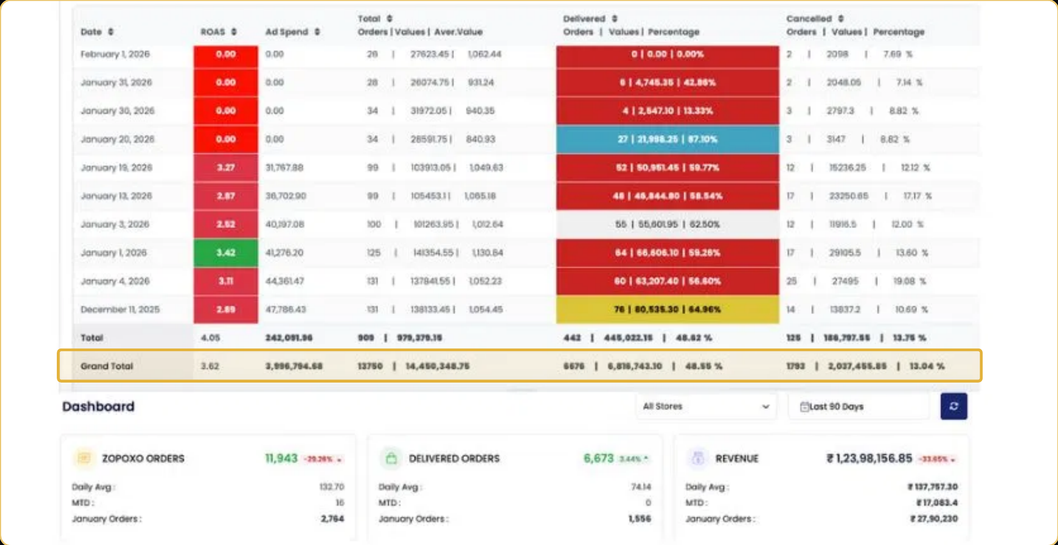
Figure 1. Original store and campaign reporting screenshot - original source image.
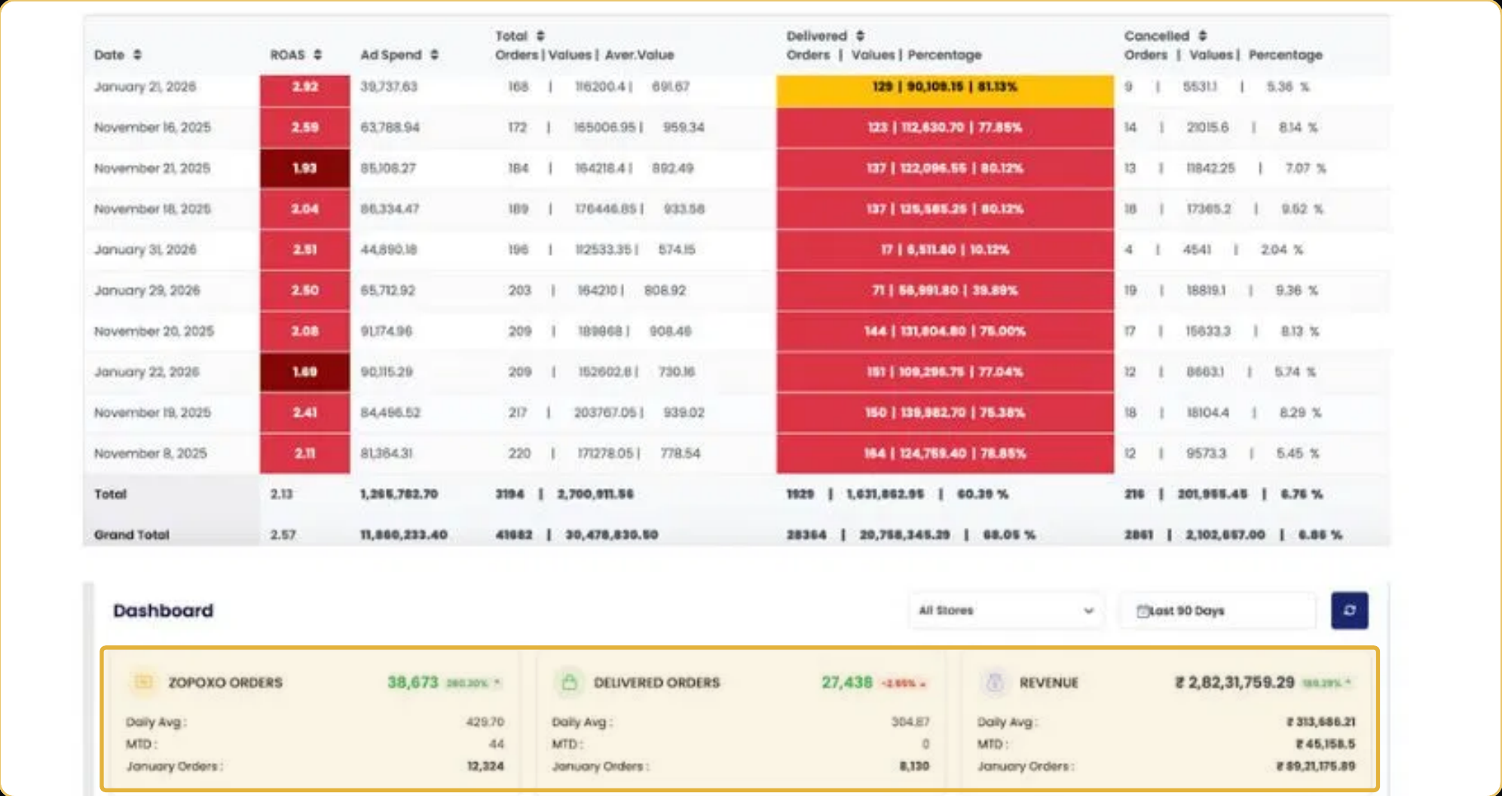
Figure 2. Original store and campaign reporting screenshot - original source image.
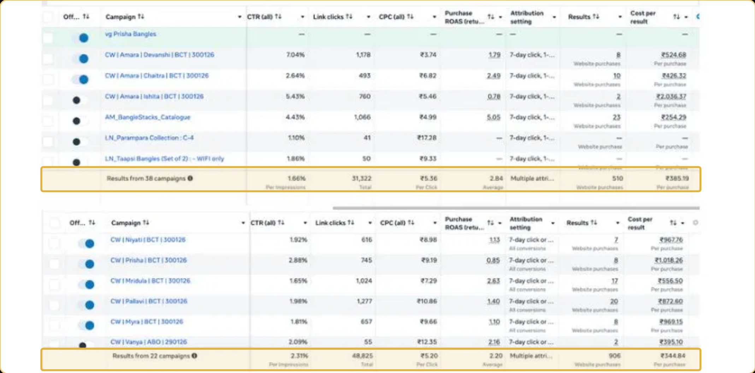
Figure 3. Original store and campaign reporting screenshot - original source image.

7. Results & Outcomes
The 90-day store snapshot reports ₹2.82 Cr in revenue and 38,673 orders, with revenue growth of 189% period over period. The account had 38 live campaigns. Strong campaigns reached 5.05x ROAS, while click-through rates reached 7.04%. The source also presents a separate daily-reporting view showing ₹1.44 Cr in order value against ₹39.97 L in ad spend, a 3.62x ratio. That daily view is a separate reporting slice and should not be added to or treated as the same total as the 90-day store revenue figure.
The reported 189% revenue growth and 38,673 orders show the scale of the store result. The 38 live campaigns show the breadth of the testing operation. The separate daily-reporting view gives a further efficiency reference at 3.62x, while individual strong campaigns reached 5.05x and CTR reached 7.04%.

What stands out in the result
The result is a combination of scale and active control: substantial store revenue and order volume were recorded while 38 campaigns were active and weak ad sets were being cut. The source also provides a separate ad-reporting view, which adds evidence of campaign efficiency when it is kept distinct from store-wide sales.

8. Key Learnings
- Use regular product and format testing in categories where creative fatigue can quickly affect performance.
- Review orders, delivery and ROAS together. Ad performance should be read alongside the ability to fulfil the demand generated.
- Do not merge store-wide sales with a separate ad-reporting view. The ₹2.82 Cr store revenue and the ₹1.44 Cr / ₹39.97 L reporting view are different records in the source.

BUSINESS VALUE AND CLOSE

9. Business Impact
The case shows a period of strong store growth alongside a large campaign-testing operation. Revenue was reported at ₹2.82 Cr over 90 days, orders reached 38,673 and revenue growth was reported at 189%. The additional campaign view gives a separate picture of ad-account efficiency. Together, these records show both store-level scale and the work involved in managing many product and creative combinations.
This is useful evidence for a jewellery business that needs volume and ongoing creative refresh. It is not a margin statement: the source does not include product costs, returns, delivery costs or contribution profit. The two revenue figures in the source must remain separate.

Business decisions this case can inform
Decision area | What the case suggests | What should be checked next
Campaign maintenance | Keep testing new designs and formats. | Product-level spend and margin.
Daily control | Review orders, delivery and ROAS together. | Delivery rate, RTO, refunds and fulfilment cost.
Revenue reporting | Keep store sales separate from the ad report view. | Confirm the date range and attribution for each dashboard.

10. Conclusion
This case shows a fashion-jewellery business using structured testing and daily review to manage a large campaign set. The store reported ₹2.82 crore revenue over 90 days, 38,673 orders and 189% growth. The ad-reporting view and store-level revenue are separate measures, and both should remain clearly labelled when this case is published.

Publishing accuracy note
The source does not disclose the brand name, exact comparison dates, gross margin, returns, cancellations, delivered-order count, product-level revenue or the exact meaning of every dashboard field. The 90-day store revenue and separate daily reporting view must remain distinct. Do not present ₹1.44 Cr / ₹39.97 L as the source of the full ₹2.82 Cr store revenue without additional confirmation.

