CASE STUDY 03 | HOMEPAGE FEATURED - RANK 5
Festive Women’s Wear D2C
$75K in spend generated $244.8K in tracked revenue

1. Case Study Overview
A fast-growing Shopify fashion label with bundle offers needed to identify stronger campaign angles and reduce spend on weaker ones. ScaleXpertz ran six approaches in parallel and shifted budget towards the activity that performed best. The full account recorded 2,448 purchases and $244.8K in tracked revenue from $75K in spend, at a reported 3.25x ROAS.
The brand was growing and had bundle offers, but it needed to learn quickly which messages and campaign angles could convert shoppers. In a fashion account, performance can differ between broad audiences, people who already know the brand, offer-led messaging, creator content, new product drops and shoppers who leave items in their carts. The case was built around testing these routes at the same time rather than relying on one creative approach.

Performance snapshot from the original case record
Metric | Reported figure
Ad spend | $75K
Tracked revenue | $244.8K
Reported ROAS | 3.25x
Purchases | 2,448
Cost per purchase | $30.77
Add-to-carts | 5,998

Homepage position: Featured case #5 in the five-case homepage selection. The complete case remains part of the full case-study library.

BUSINESS CONTEXT

2. The Challenge
The central challenge was to find winning angles without continuing to fund weaker ones. The account also had a large group of shoppers showing purchase intent: 5,998 add-to-carts were recorded. That made cart recovery an important part of the execution, alongside discovery and retargeting. The source does not identify the exact products, bundle price points or the split of the $75K budget across the six approaches.
The account needed to make decisions quickly. A weaker angle could continue spending if it was not compared with other options. At the same time, the large add-to-cart count meant there was a group of shoppers who had shown interest but had not yet completed an order.

What made this case difficult
There were six angles to compare and 5,998 add-to-carts in the account snapshot. That made it important to look beyond top-of-funnel traffic and pay attention to cart recovery. The source does not provide the number of abandoned carts or the share recovered, so those rates cannot be calculated.

Practical effect on the business
Without a separate recovery activity, shoppers who have already added a product to their cart may not receive a dedicated follow-up. The 5,998 add-to-carts in this case make that group important, while the 480 cart-recovery purchases show that follow-up was a measurable part of the result.

3. Objective
The source describes a need to find winning angles quickly and stop paying for losing ones. This makes campaign learning and budget allocation central to the case. No pre-campaign numerical target is supplied, so the outcome is judged through the reported spend, purchases, revenue, ROAS and results from the strongest sub-campaigns.
The work needed to identify stronger angles, reduce spend on weaker ones and convert shoppers who had already added items to their carts. The full account figures and the cart-recovery figures allow the result to be reviewed at both account and campaign level. No specific target before launch is stated.

Objective and available success measures
Objective area | Evidence available in the source
Account growth | $244.8K tracked revenue from $75K spend
Purchase volume | 2,448 purchases
Cart recovery | 480 purchases at 6.85x ROAS
Shopping intent | 5,998 add-to-carts

APPROACH AND DELIVERY

4. Strategy
The strategy was to test six buying angles at the same time instead of making the whole account depend on one message. The mix covered broad reach, retargeting, value-led offers, creator try-on content, new-drop activity and cart recovery. Each angle addressed a different reason a shopper might buy or delay a purchase.
Budget was moved towards the activity that the results supported. This matters in a fast-moving fashion account because a strong offer or creative can perform differently from a general product message. Cart recovery and embroidered-edit retargeting were clear winners in the reported results, while the full account continued to generate purchases at scale.

How the strategy addressed the business need
The strategy linked discovery, offer testing and follow-up. Its strongest reported outcome came from cart recovery, but the other angles remained part of an account that delivered 2,448 purchases overall.

Why this structure fits the case
Testing six angles in parallel created comparisons across different buying motivations. A shopper may respond to an offer, a creator demonstrating the product, a new collection or a reminder about an item left in the cart. The case does not show the exact creative, but it shows that the account was not relying on one message and that the budget was moved towards the activity returning stronger results.

5. Campaign Execution
The team ran broad campaigns, retargeting, value-offer campaigns, creator try-on video, new-drop scaling and cart recovery. Each approach addressed a different point in the shopping journey. Broad activity could reach new prospects, retargeting could reconnect with people already familiar with the brand, offer-led campaigns could make the bundle proposition clearer, and creator try-on video could show how the clothing looked in use. New-drop scaling supported fresh collection activity, while cart recovery focused on shoppers who had added products but had not completed a purchase. Budget was moved towards the activity rewarded by the results. The source does not provide audience definitions, exact creative examples, placements or the full budget split, so these are not invented.

Campaign or activity breakdown
Campaign / activity | Role in the account | Reported evidence
Broad and retargeting | Reach new shoppers and reconnect with interested shoppers | Embroidered-edit retargeting: 5.24x
Value offers and creator try-on video | Test offer-led and creator-led angles | Individual figures not stated
New-drop scaling | Support activity around new product drops | Individual figures not stated
Cart recovery | Follow up with shoppers who added products to cart | 480 purchases; $16.68 cost per purchase; 6.85x ROAS

The six angles are named in the original case. Apart from the cart-recovery and embroidered-retargeting results, separate results for every angle are not included.
The six angles covered both the first visit and the return visit. Broad activity supported discovery; retargeting and cart recovery addressed people who had already interacted with the store; value offers gave shoppers a price-led reason to act; creator try-on content showed the products in use; and new-drop scaling supported fresh collection activity. The source does not report a separate spend or result for every angle, so only cart recovery and embroidered-edit retargeting are highlighted as named performers.

NUMBERS AND REPORTING

6. Performance Analysis

Reading the main metrics
The account-level result was $244.8K in tracked revenue from $75K spend, reported as 3.25x ROAS. The $30.77 cost per purchase is the account-level figure. Cart recovery was more efficient at 6.85x and $16.68 per purchase, but it contributed 480 purchases rather than all 2,448 account purchases. The 5,998 add-to-carts are not the same as completed orders.
Cart recovery recorded 480 purchases out of the account total of 2,448, or roughly one fifth of all reported purchases. Its $16.68 cost per purchase was lower than the account-level $30.77 figure. This makes it the clearest efficiency example in the case. The add-to-cart total of 5,998 shows the size of the recorded shopping-intent pool, but the source does not confirm that all those add-to-carts belonged to the same people or period as the cart-recovery purchases.

What the figures do and do not show
The source does not provide product margins, refund rates, repeat purchases or campaign dates. The cart-recovery result is a campaign-level outcome within the overall account. It should not be presented as though all 5,998 add-to-carts became purchases.
Metric | Reported figure
Ad spend | $75K
Tracked revenue | $244.8K
Reported ROAS | 3.25x
Purchases | 2,448
Cost per purchase | $30.77
Add-to-carts | 5,998

Original Dashboard Evidence
The following images are the original screenshots supplied in the source case-study document. They are included as visual supporting evidence and have not been altered.
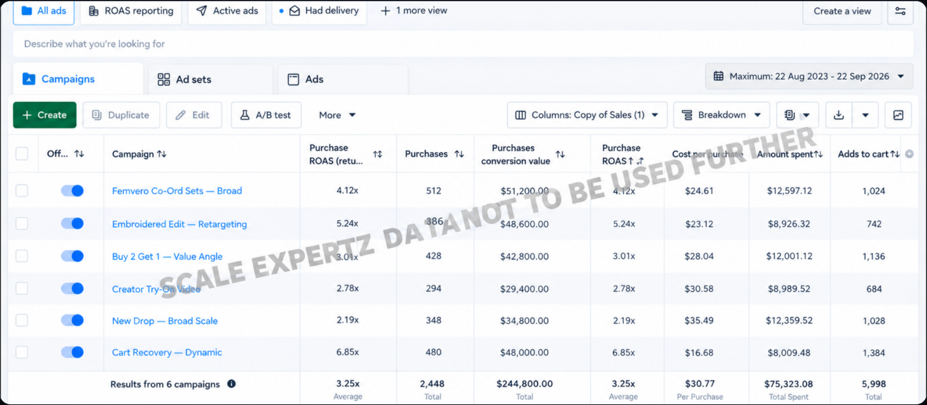
Figure 1. Meta Ads campaign dashboard screenshot - original source image.

7. Results & Outcomes
The complete account recorded $244.8K in tracked revenue from $75K in spend, with a reported 3.25x ROAS. It generated 2,448 purchases at a reported $30.77 cost per purchase. Cart recovery was the standout sub-campaign: 480 purchases at $16.68 each and a reported 6.85x ROAS. Retargeting for the embroidered edit delivered 5.24x. The account also recorded 5,998 add-to-carts. These results show that the overall account performance and the performance of individual campaign angles were not identical; the cart-recovery and embroidered-edit results were notably stronger than the account-wide average.
Cart recovery produced 480 purchases, representing a defined part of the account's 2,448 purchases. Its 6.85x ROAS and $16.68 cost per purchase were stronger than the overall account figures. Embroidered-edit retargeting also reached 5.24x. These named examples explain which parts of the six-angle approach performed particularly well.

What stands out in the result
The strongest result came from people who had already shown purchase intent. Cart recovery produced a lower cost per purchase than the account average and 6.85x ROAS. This is a clear example of how a specific part of the customer journey contributed to the full account outcome.

8. Key Learnings
- Test different purchase reasons in parallel, including offers, creator content, new drops and cart recovery.
- Cart recovery deserves its own view. In this account it produced 480 purchases at 6.85x ROAS and a $16.68 cost per purchase.
- Move budget based on observed results, while keeping account-level outcomes separate from the strongest individual campaign.

BUSINESS VALUE AND CLOSE

9. Business Impact
The account produced 2,448 purchases and $244.8K in tracked revenue during the reported period. The add-to-cart figure shows that a much larger group of shoppers reached a point of shopping intent, while the cart-recovery result demonstrates the value of following up with that audience.
For business planning, this case highlights the role of recovery campaigns and the need to compare campaign angles before shifting budget. It does not establish net profit or the share of total sales that was incremental.

Business decisions this case can inform
Decision area | What the case suggests | What should be checked next
Recovery investment | Cart recovery was the most efficient named angle. | Recovery rate, margin and incremental orders.
Creative mix | Compare value offers, creator content and new-drop activity. | Separate results for each of the six angles.
Commercial review | Use the 2,448 purchases as the account-level outcome. | Returns, discounts and contribution margin.

10. Conclusion
This case shows a fashion account using six angles to compare how shoppers respond to broad campaigns, offers, creator content, new drops and cart recovery. The account reported $244.8K in tracked revenue from $75K spend, with 2,448 purchases and 3.25x ROAS. Cart recovery was the strongest named angle, returning 6.85x and 480 purchases.

Publishing accuracy note
The source does not identify the brand, exact campaign dates, offer values, product prices, gross margin or revenue attribution settings. It does not provide individual results for all six angles. The $75K spend and $244.8K revenue are account-level figures; the 6.85x and 5.24x figures refer to specific campaign groups and should not be substituted for the account average.

