CASE STUDY 02 | SEE ALL LIBRARY
Contemporary Ethnic Wear
987 purchases and $98.7K in tracked revenue

1. Case Study Overview
An omnichannel fashion label with an established customer base wanted its online store to perform in line with the energy of its physical retail business. ScaleXpertz organised campaigns around occasion-led product families and used several campaign types side by side. Six campaigns generated 987 purchases and $98.7K in tracked revenue, at a reported 2.98x ROAS.
The business already had a loyal customer base and physical retail presence. The opportunity described in the source was to make the online store a stronger part of the brand experience. Fashion demand is often shaped by product type, occasion and the way a collection is presented. The account was therefore built around hero product families rather than treating the entire catalogue as one undifferentiated offer.

Performance snapshot from the original case record
Metric | Reported figure
Tracked revenue | $98.7K
Reported ROAS | 2.98x
Purchases | 987
Cost per purchase | $33.55
Campaigns | 6
Lead broad campaign | 241 purchases / $25.8K

BUSINESS CONTEXT

2. The Challenge
The task was to create online purchase volume while keeping performance consistent across multiple collections and campaign types. The source identifies sets, co-ords, dresses and festive layers as the key product families. A single ad or product line was not expected to carry the entire account. Campaigns for broad discovery, retargeting, video and dynamic formats ran alongside one another to distribute the work.
The online store had to support a business that already had physical retail and a loyal customer base. That meant the task was not simply to generate traffic. The campaigns needed to present several fashion categories clearly and produce a steady level of online orders across those categories.

What made this case difficult
The challenge had two sides: the store needed volume, and the campaign results needed to stay reasonably consistent. The reported range of 2.64x to 3.21x across six campaigns is relevant because it shows the result was spread across the campaign set rather than being described as one isolated winner.

Practical effect on the business
For fashion, a strong overall result can hide differences between product groups. Keeping the collection families visible helps a team decide whether the next focus should be sets, co-ords, dresses or festive layers, rather than making that decision from the account total alone.

3. Objective
The stated aim was to bring the online store closer to the strength of the physical retail business. The source does not provide a formal revenue target or a defined launch date. The result is therefore described through the actual recorded purchase volume, revenue, reported ROAS and consistency across six campaigns.
The objective was to strengthen online sales while supporting several fashion collections. The measurable outcomes available for review are purchases, tracked revenue, reported ROAS, cost per purchase and the spread of ROAS across the six campaigns. No formal target or launch date is given.

Objective and available success measures
Objective area | Evidence available in the source
Online purchase volume | 987 purchases across six campaigns
Tracked sales | $98.7K reported revenue
Campaign consistency | ROAS range of 2.64x to 3.21x
Cost efficiency | $33.55 reported cost per purchase

APPROACH AND DELIVERY

4. Strategy
The account followed the way customers shop an ethnic-wear collection. Sets, co-ords, dresses and festive layers were treated as separate product families rather than being pushed as one large catalogue. This gives each collection a clearer role in the advertising account and helps the team see which category is attracting orders.
The campaign mix also included broad prospecting, retargeting, video and dynamic campaigns. These formats served different needs: finding shoppers, reconnecting with previous visitors and showing products in formats suited to browsing a fashion range. The source does not provide the exact audience rules or budget split, so the strategy is described at the level of the campaign structure that was reported.

How the strategy addressed the business need
The approach made the fashion range easier to organise and compare. It also reduced reliance on one ad format: broad, retargeting, video and dynamic campaigns all formed part of the six-campaign account.

Why this structure fits the case
This structure gives the team two useful views at once: how each product family performs and how each campaign type performs. It can help separate a product issue from a format issue. For example, a weaker result may come from the product family, the audience or the format, and the source's structure provides a way to review those dimensions rather than treating the whole store as one result.

5. Campaign Execution
The campaign structure followed the way customers could browse the fashion range. Sets, co-ords, dresses and festive layers each had a separate campaign focus. Broad and prospecting campaigns supported discovery, while retargeting addressed people who had already interacted with the brand. Video and dynamic campaigns added further formats to the account. This meant that the performance of one creative or one product family did not have to determine the whole account. The source reports six campaigns and says that each campaign sat between 2.64x and 3.21x ROAS. The lead broad campaign delivered 241 purchases and $25.8K in tracked revenue. Specific audiences, creative scripts, product pricing, discount levels and the exact budget split are not given in the source.

Campaign or activity breakdown
Campaign / activity | Role in the account | Reported evidence
Occasion-led product groups | Separate focus for sets, co-ords, dresses and festive layers | Individual product-family results not stated
Broad / prospecting | Support discovery across the account | Lead broad campaign: 241 purchases and $25.8K
Retargeting, video and dynamic campaigns | Run different campaign types side by side | All six campaigns ranged from 2.64x to 3.21x

The source confirms six campaigns and the campaign types listed above. It does not provide each campaign's budget, audience definition, creative script, offer value or individual result by product family.
The product-family organisation helped keep the fashion range visible as separate shopping choices. Sets, co-ords, dresses and festive layers were not treated as one single product group. Broad and prospecting campaigns provided reach, while retargeting, video and dynamic formats gave the account additional ways to engage people with the range. The six-campaign result is reported as a total, with the broad campaign identified as the largest named contributor.

NUMBERS AND REPORTING

6. Performance Analysis

Reading the main metrics
The reported 2.98x ROAS is the account-level return, while 2.64x to 3.21x is the range across the six campaigns. Cost per purchase was $33.55. The lead broad campaign's 241 purchases and $25.8K in tracked revenue are a campaign-level result, not the account total. The total account result remains 987 purchases and $98.7K.
The lead broad campaign contributed about one quarter of the account's purchase count (241 of 987) and about one quarter of its tracked revenue ($25.8K of $98.7K). These are simple comparisons based on the rounded figures in the source. The campaign ROAS range was 2.64x to 3.21x, a spread of 0.57x. This gives more context than quoting only the 2.98x account average.

What the figures do and do not show
The source does not identify the brand, campaign dates, total ad spend, gross margin or the breakdown by product family. The reported tracked revenue should not be described as the brand's entire business revenue or as profit.
Metric | Reported figure
Tracked revenue | $98.7K
Reported ROAS | 2.98x
Purchases | 987
Cost per purchase | $33.55
Campaigns | 6
Lead broad campaign | 241 purchases / $25.8K

Original Dashboard Evidence
The following images are the original screenshots supplied in the source case-study document. They are included as visual supporting evidence and have not been altered.
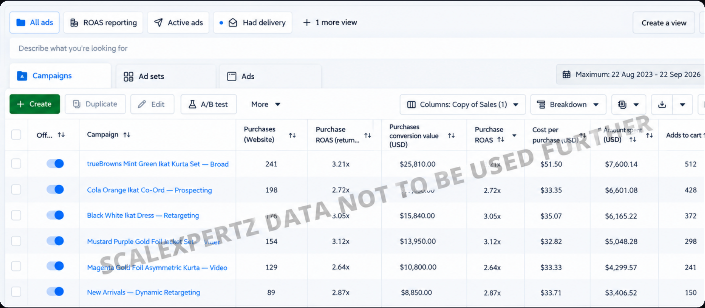
Figure 1. Meta Ads campaign dashboard screenshot - original source image.

7. Results & Outcomes
The account recorded 987 purchases, $98.7K in tracked revenue and a reported 2.98x ROAS. Cost per purchase was reported at $33.55. The lead broad campaign alone produced 241 purchases and $25.8K. Across the six campaigns, reported ROAS ranged from 2.64x to 3.21x. That narrow range is an important part of the story: performance was not described as coming from one isolated winner. Several campaign groups contributed within a relatively consistent band.
The lead broad campaign contributed 241 of the 987 purchases and $25.8K in tracked revenue. The rest of the campaign set also contributed, with all six reported campaigns falling between 2.64x and 3.21x ROAS. This is why consistency is a key result alongside total purchase volume.

What stands out in the result
The result is notable for consistency across six campaigns. The broad campaign was the largest named contributor, but the full set stayed within a relatively close ROAS range. That gives the case a stronger message about repeatable account performance than a story based only on one campaign.

8. Key Learnings
- Organise fashion advertising around the way customers browse: product family, collection and occasion can be clearer organising points than one all-products message.
- Use several campaign types so discovery, follow-up and product presentation do not depend on one creative format.
- Read consistency across the account as well as the best campaign. The six reported campaigns stayed within a 2.64x to 3.21x ROAS range.

BUSINESS VALUE AND CLOSE

9. Business Impact
The account delivered almost 1,000 purchases while keeping the reported return of its six campaigns within a relatively narrow range. For an omnichannel fashion business, this creates a clearer way to compare online product families and to decide where the online store should receive attention as collections change.
The case demonstrates tracked online revenue and purchase activity. It does not prove that the ads generated every sale, nor does it provide margin or repeat-customer data. Its business value is the scale and consistency of the recorded campaign results.

Business decisions this case can inform
Decision area | What the case suggests | What should be checked next
Collection focus | Review sets, co-ords, dresses and festive layers as distinct groups. | Revenue and margin by product family.
Campaign balance | Six campaigns reported a tight ROAS range. | Spend split and audience overlap.
Season planning | Use the online result as a reference for future collection activity. | Season-to-season comparison and repeat buying.

10. Conclusion
This case shows an omnichannel ethnic-wear brand building online purchase volume through campaigns organised around product families and different formats. Six campaigns produced 987 purchases and $98.7K in tracked revenue at 2.98x ROAS. The narrow performance range across campaigns is as important as the total result because it shows that the account did not rely on one isolated winner.

Publishing accuracy note
The source does not identify the brand, campaign dates, total ad spend, gross margin, average order value, repeat purchases, audience size or the specific definition of tracked revenue. It also does not provide separate results for every product family. No claim about profit, customer lifetime value or incremental sales should be added without further evidence.

